**DevOps Task: Deploying a Web App on Azure**

**Objective:**

Welcome to an exciting journey into the world of cloud infrastructure, containerization, and automation! This adventure will guide you through deploying a sleek web application using HTML and CSS on Azure Free Tier. By the end, you'll be proficient in setting up essential resources like Virtual Machines (VMs), Azure Kubernetes Service (AKS), and Azure Container Registry (ACR). You'll also master containerizing applications with Docker and automating deployments with Azure DevOps pipelines. The goal? To provide hands-on experience in DevOps practices, Continuous Integration/Continuous Deployment (CI/CD) workflows, and optimizing resources within the free-tier limits.

**Requirements and Tools Needed**

**Azure Free Tier Account** *Unlock access to a world of Azure services.*

**Azure CLI** *Your command-line tool to manage Azure resources effortlessly.*

**Docker** *The powerhouse for containerizing your web application.*

**Kubectl** *Your trusty sidekick for interacting with Kubernetes clusters.*

**Git** *Version control at your fingertips.*

**Visual Studio Code (optional)** *For code editing that feels like a breeze.*

**Azure DevOps Account** *Setup CI/CD pipelines like a pro.*

**Web Development Knowledge** *A foundational understanding of HTML, CSS, Docker, Kubernetes, ACR, and Kubernetes clusters.*

**Azure Container Registry (ACR)** *Azure’s premier service for storing and managing Docker container images.*

**Kubernetes** *The maestro orchestrating the management of containerized applications.*

**Kubernetes Cluster** *A robust set of nodes managed by Kubernetes to run your containerized apps.*

**Manual Deployment Using Bash Script**

Unleash the power of automation by manually deploying your web application with a Bash script. This guide provides the essential steps, including :

1. **Creating Azure Resources** Set up the cloud infrastructure to host your application.
2. **Containerizing the Application with Docker** Wrap your web app in a Docker container for smooth deployment.
3. **Pushing the Docker Image to ACR** Securely store and manage your container images in Azure Container Registry.
4. **Deploying on AKS** Deploy your Dockerized application on Azure Kubernetes Service for scalable management.

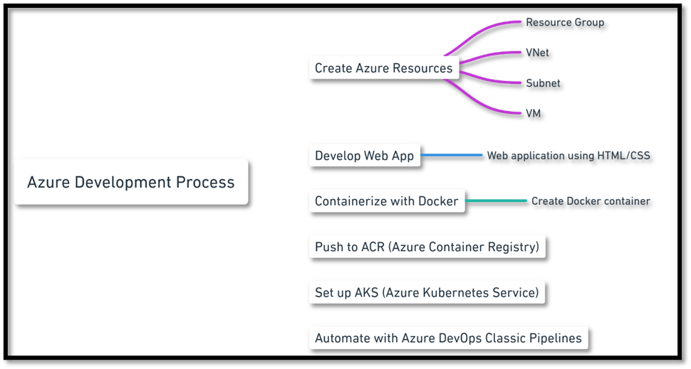

**Login to the Azure portal:**

**Open Bash:** Write **az login** in the Bash CLI in the azure portal

**Create a resource group**  
az group create --name CDPGenCTechServices-2355381-Persistent-RG --location CentralUS

**Create a virtual network**  
az network vnet create --resource-group CDPGenCTechServices-2355381-Persistent-RG --name MyVnet --address-prefix 10.0.0.0/16 --subnet-name MySubnet --subnet-prefix 10.0.0.0/24

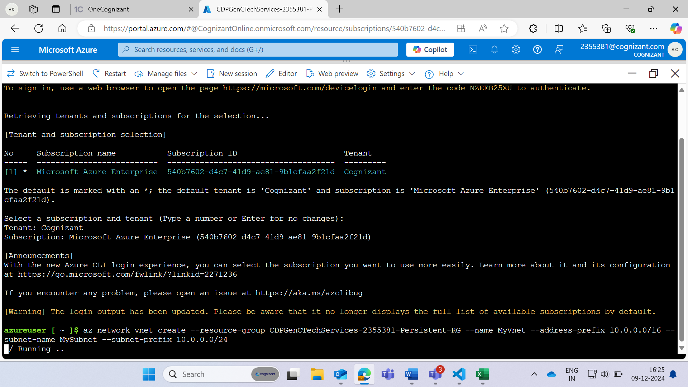

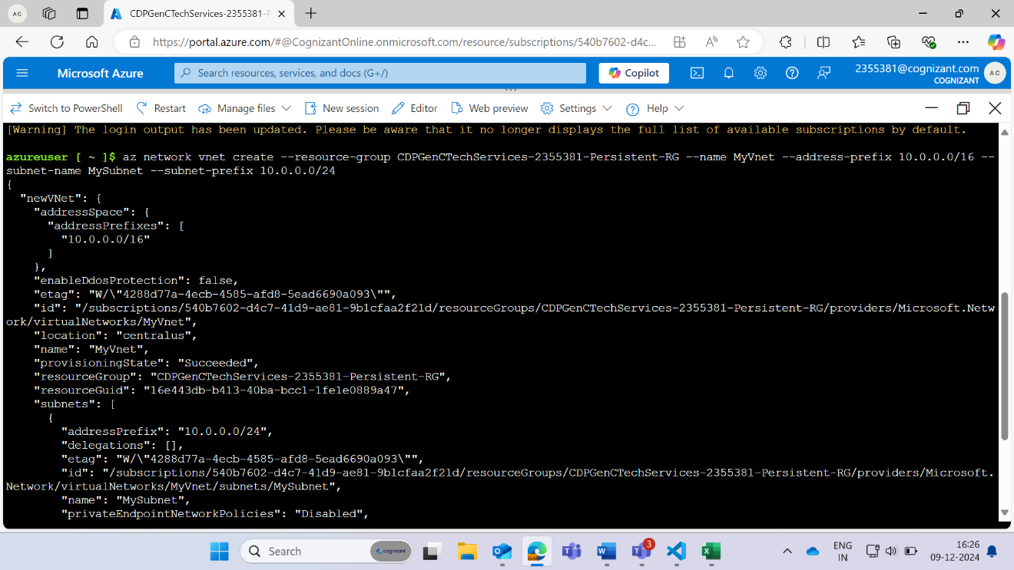

**Create a network security group**

az network nsg create --resource-group CDPGenCTechServices-2355381-Persistent-RG --name MyNsg

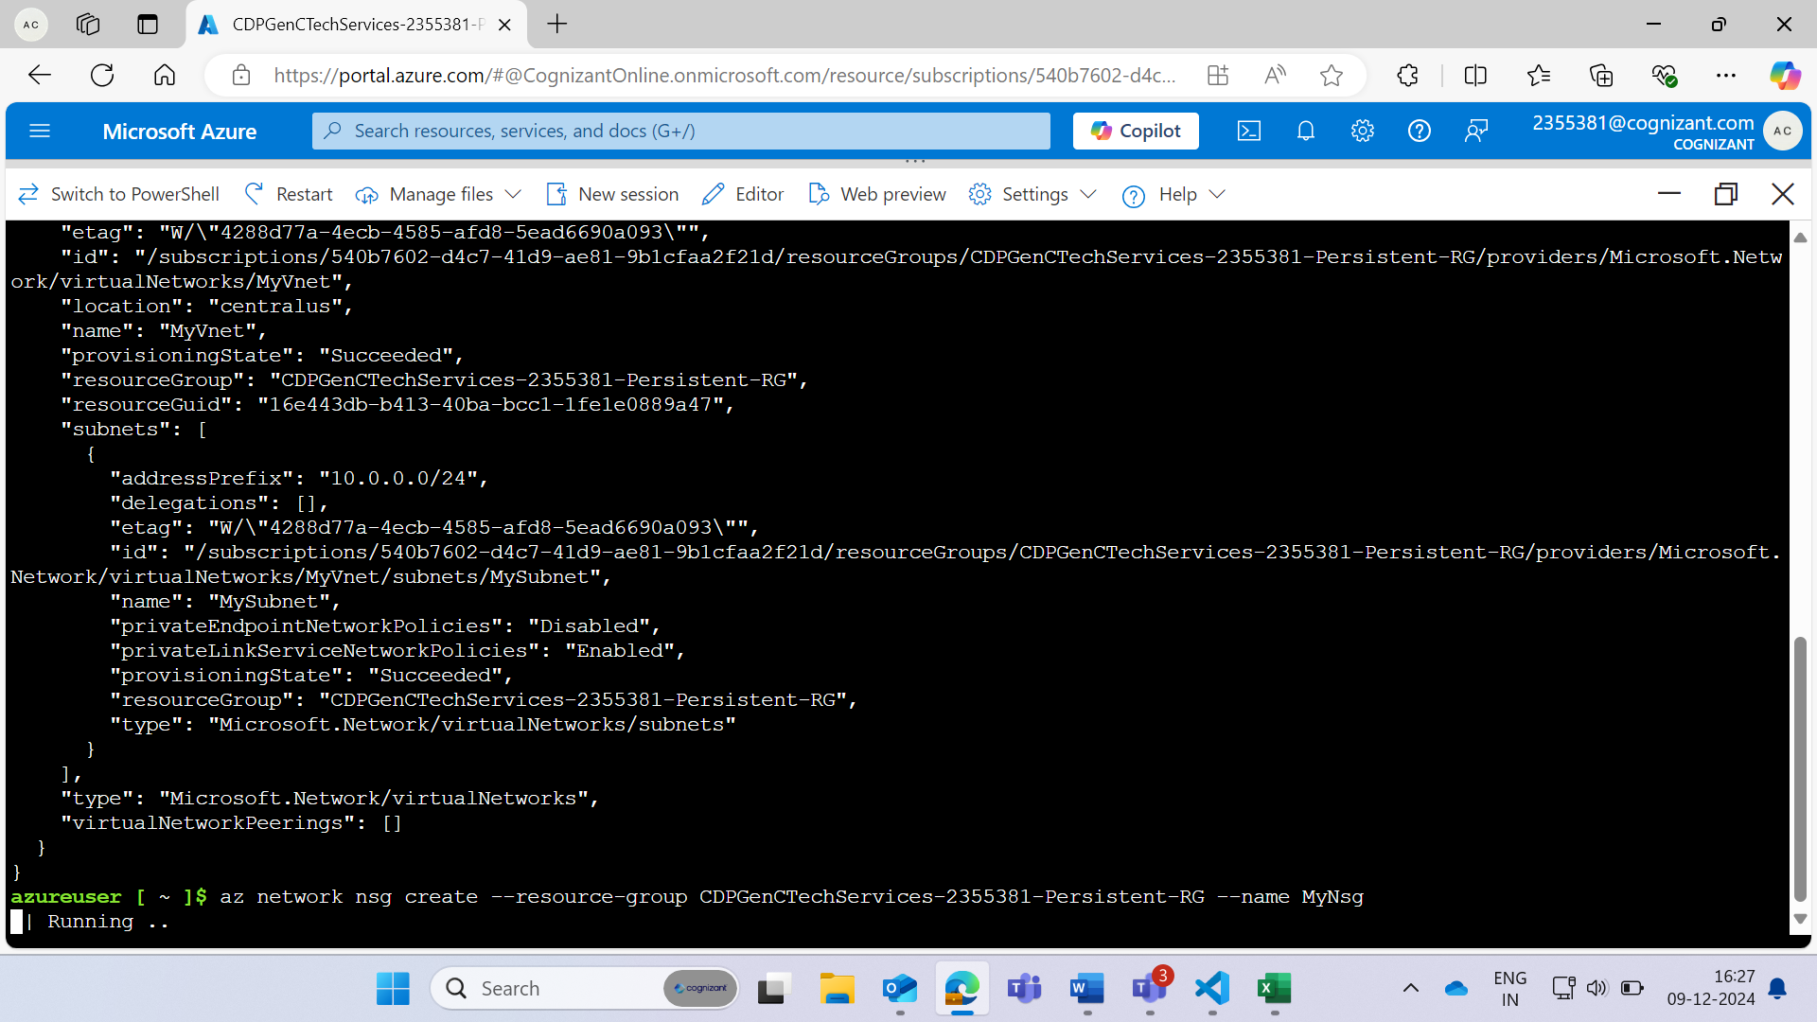

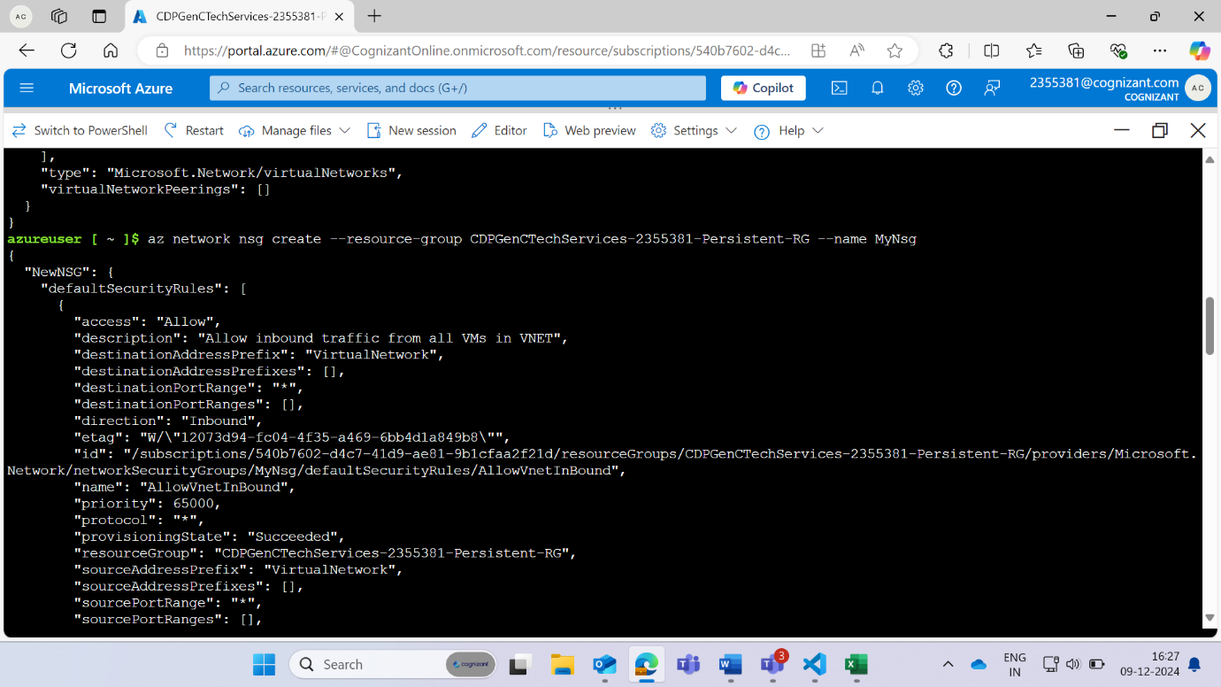

**Create network security group rules to allow ports 22**

az network nsg rule create --resource-group CDPGenCTechServices-2355381-Persistent-RG --nsg-name MyNsg --name AllowSSH --protocol tcp --direction inbound --priority 1000 --source-address-prefix '*' --source-port-range '*' --destination-address-prefix '*' --destination-port-ranges 22 --access allow

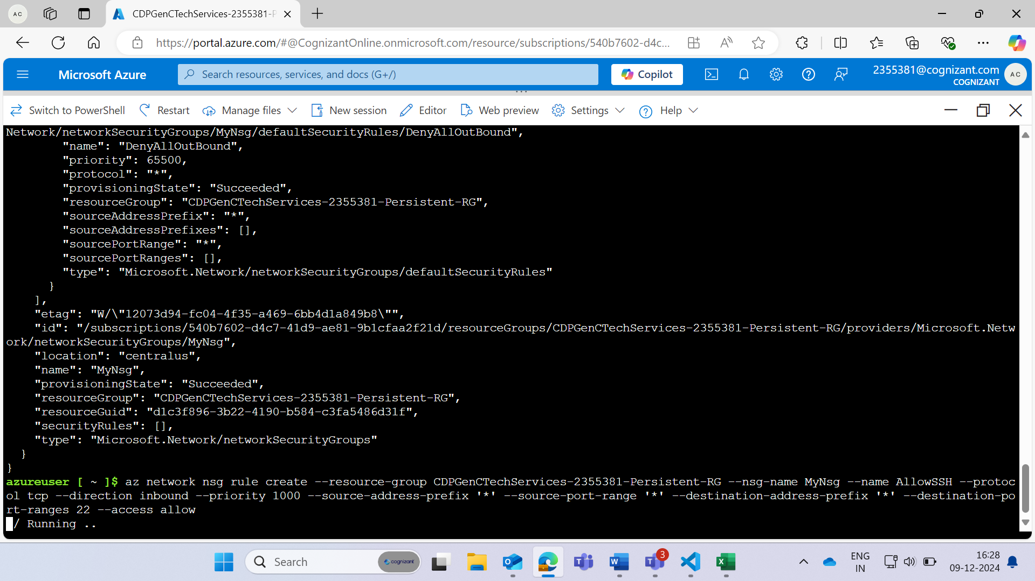

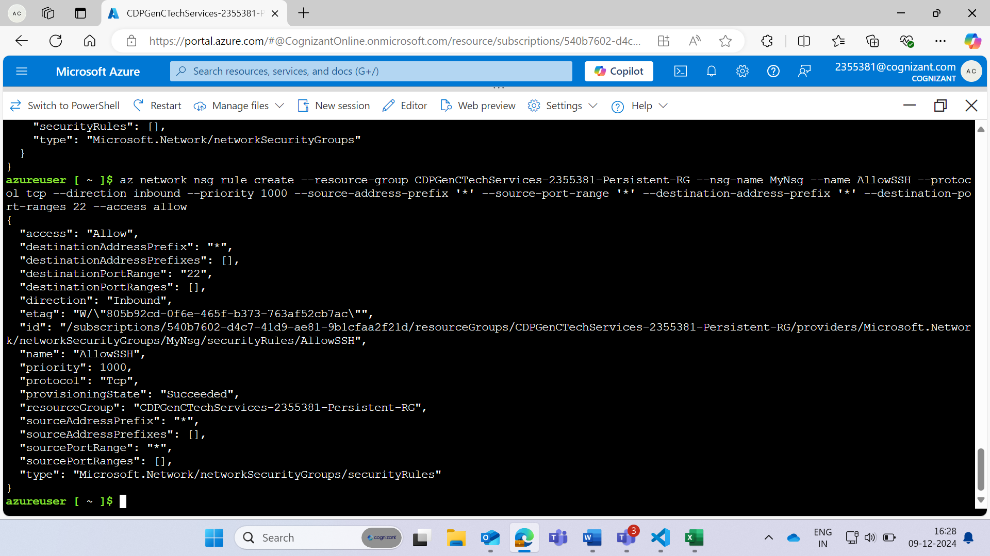

**Create network security group rules to allow ports 80**

az network nsg rule create --resource-group CDPGenCTechServices-2355381-Persistent-RG --nsg-name MyNsg --name AllowHTTP --protocol tcp --direction inbound --priority 1001 --source-address-prefix '*' --source-port-range '*' --destination-address-prefix '*' --destination-port-ranges 80 --access allow

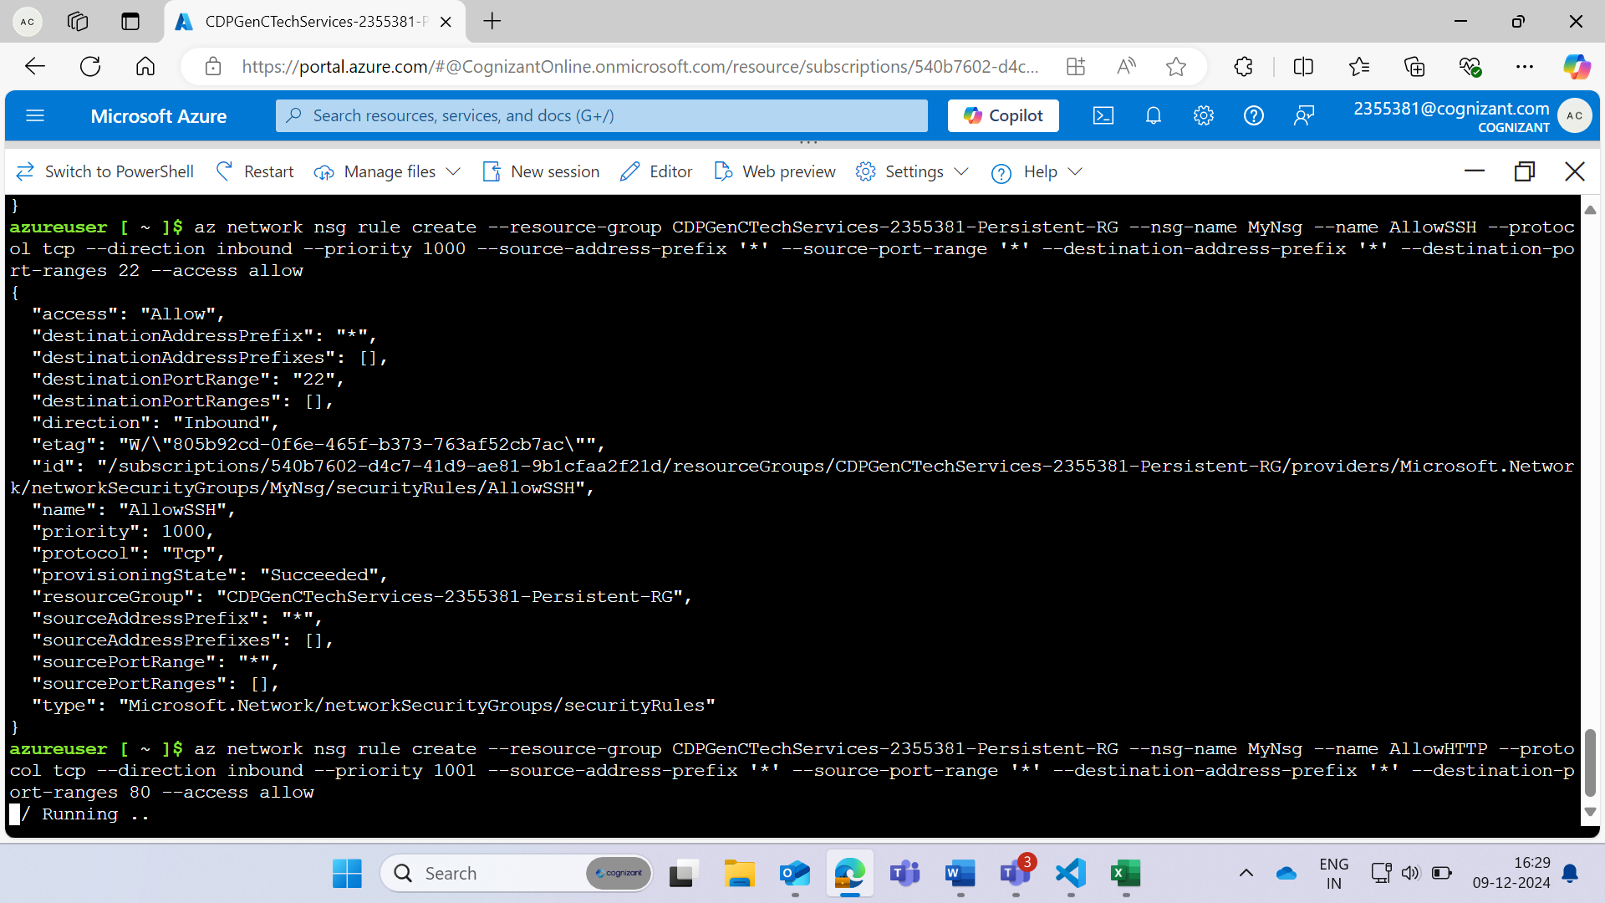

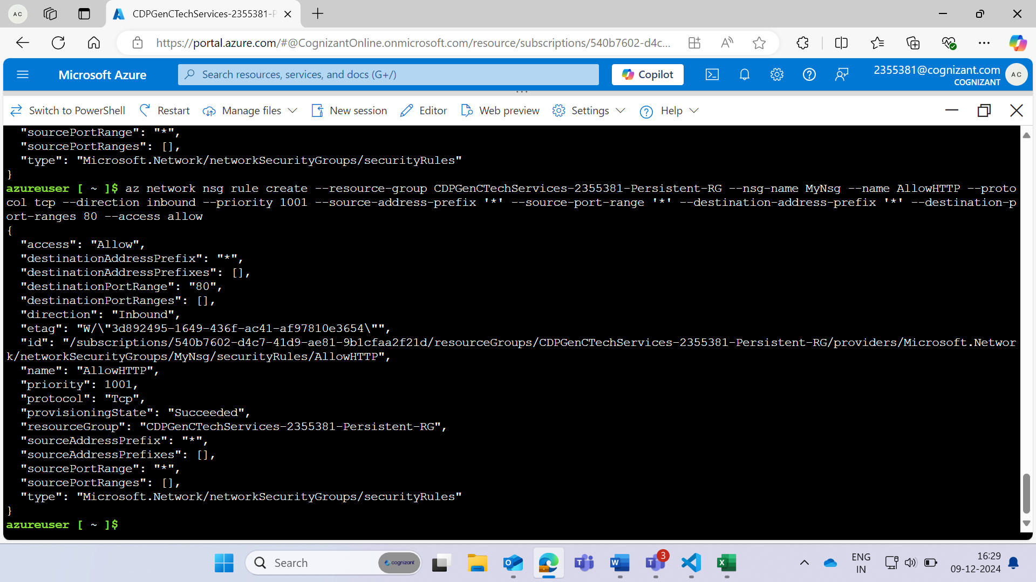

**Create a public IP address**

az network public-ip create --resource-group CDPGenCTechServices-2355381-Persistent-RG --name MyPublicIP

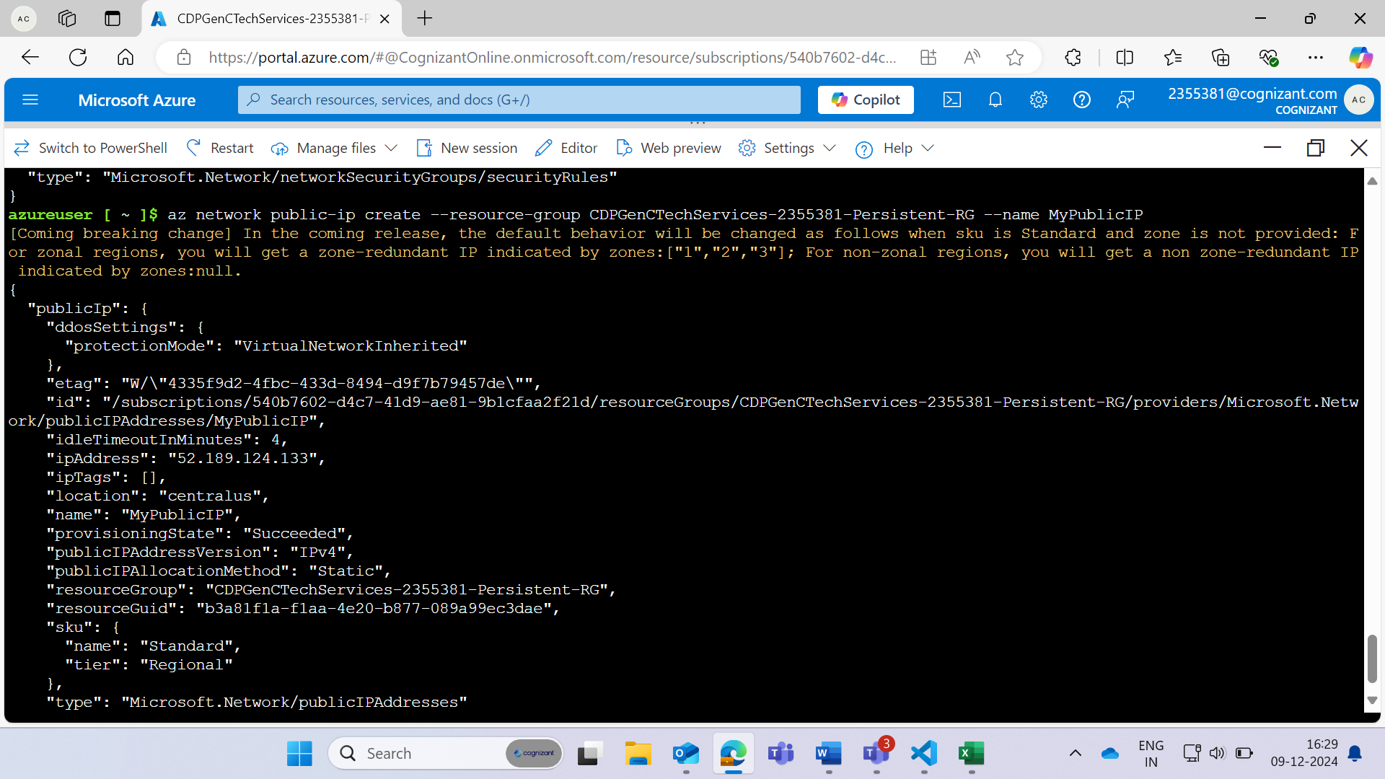

**Create a network interface card (NIC) and associate it with the public IP address and NSG**

az network nic create --resource-group CDPGenCTechServices-2355381-Persistent-RG --name MyNic --vnet-name MyVnet --subnet MySubnet --network-security-group MyNsg --public-ip-address MyPublicIP

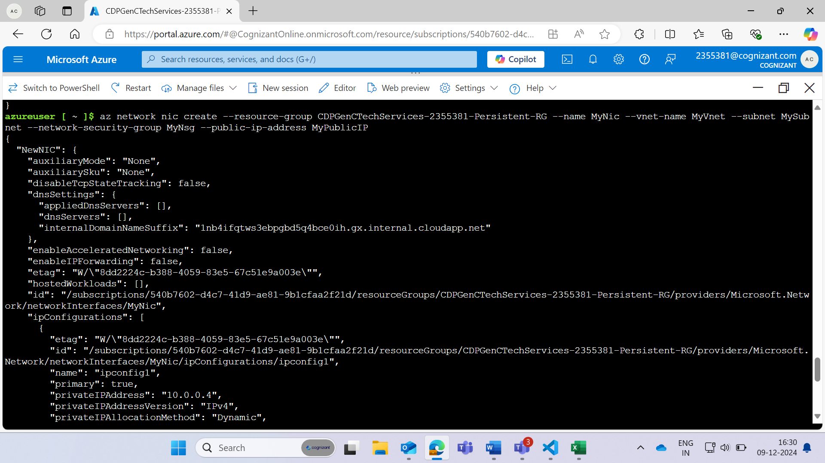

**Create the virtual machine**

az vm create --resource-group CDPGenCTechServices-2355381-Persistent-RG --name AkhilUseCase --image Ubuntu2204 --size Standard_B1s --admin-username akhilesh --admin-password Akhilesh@2407 --nics MyNic --location CentralUS --tags Project=DevEnvironment Purpose="Development environment to host tools and test applications"  
.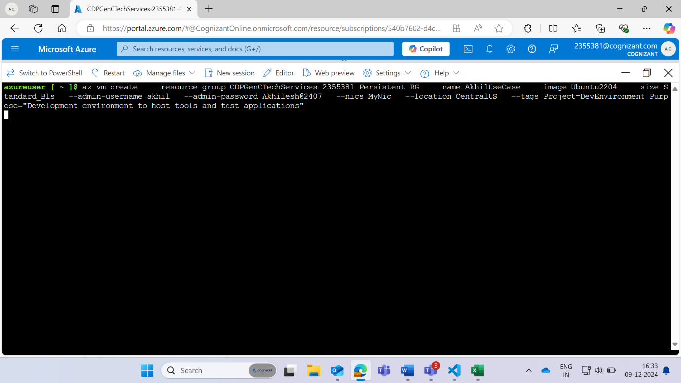

**The Command is running to create a virtual machine in azure portal**

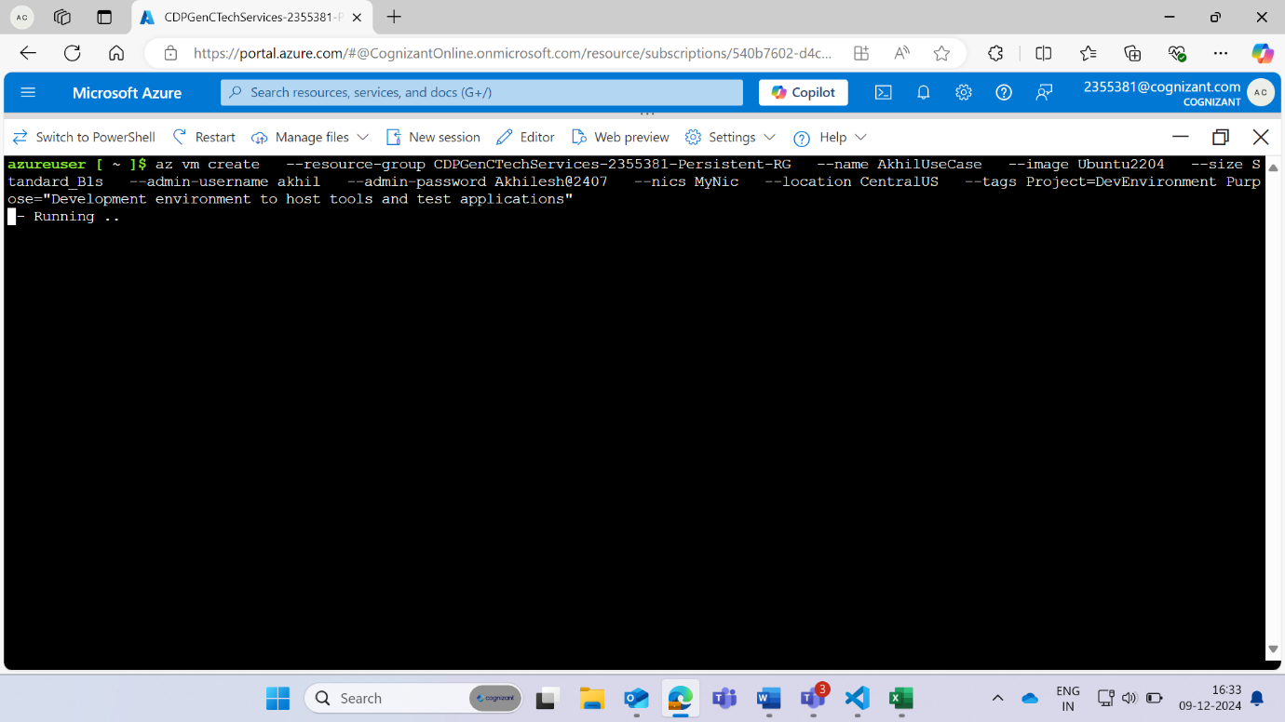

**Virtual Machine is Created**

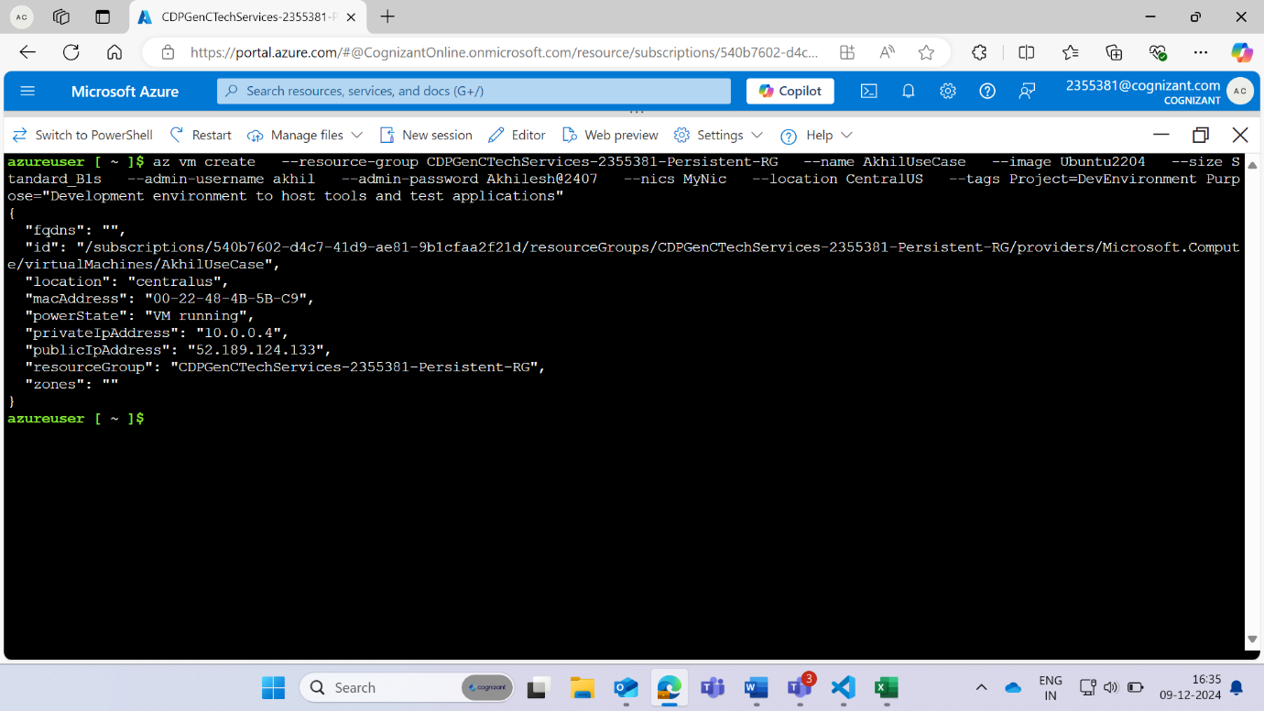

**Resources and Virtual Machine wich is being created after running the command in bash**

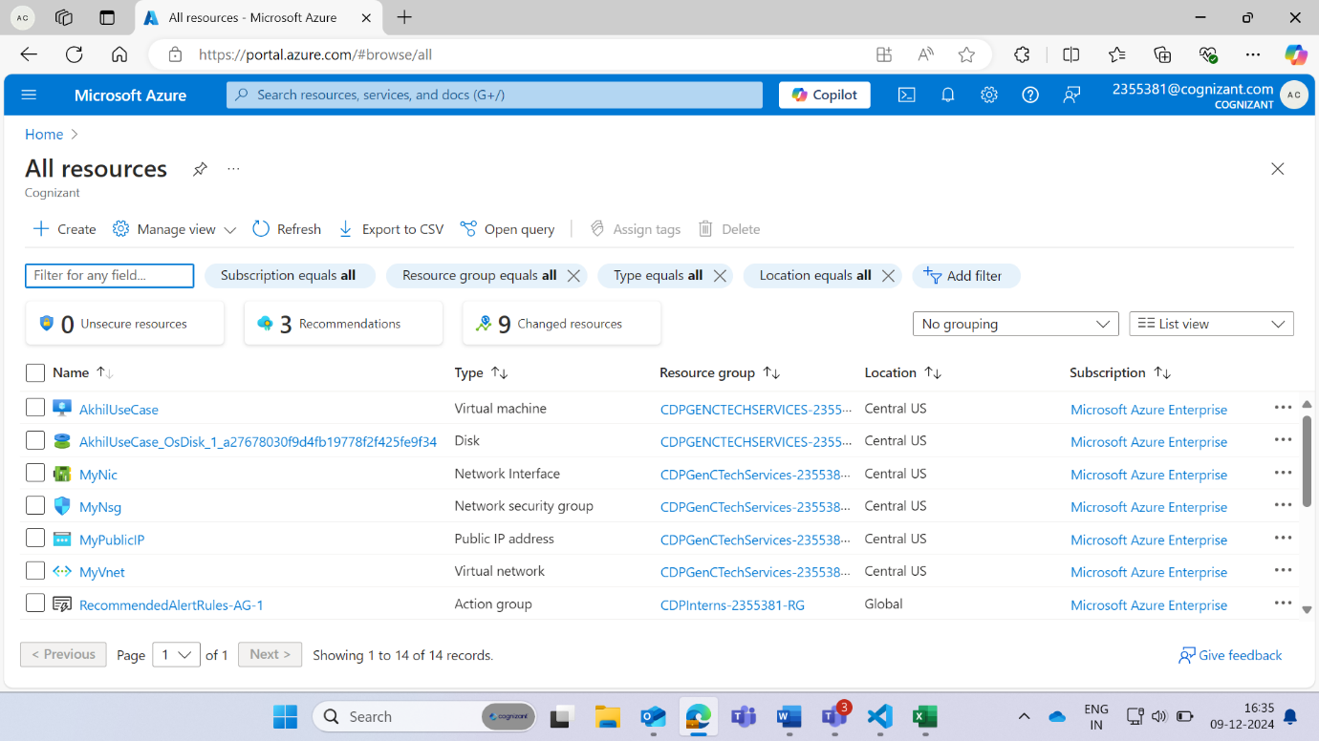

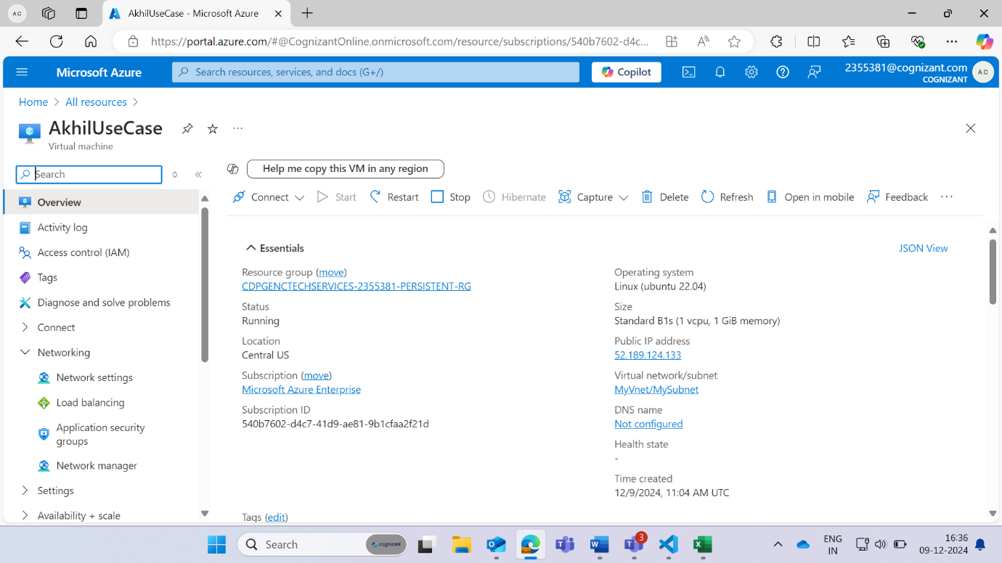

**Now Using SSH we connect the virtual machine with the bash CLI so that we can work on it**

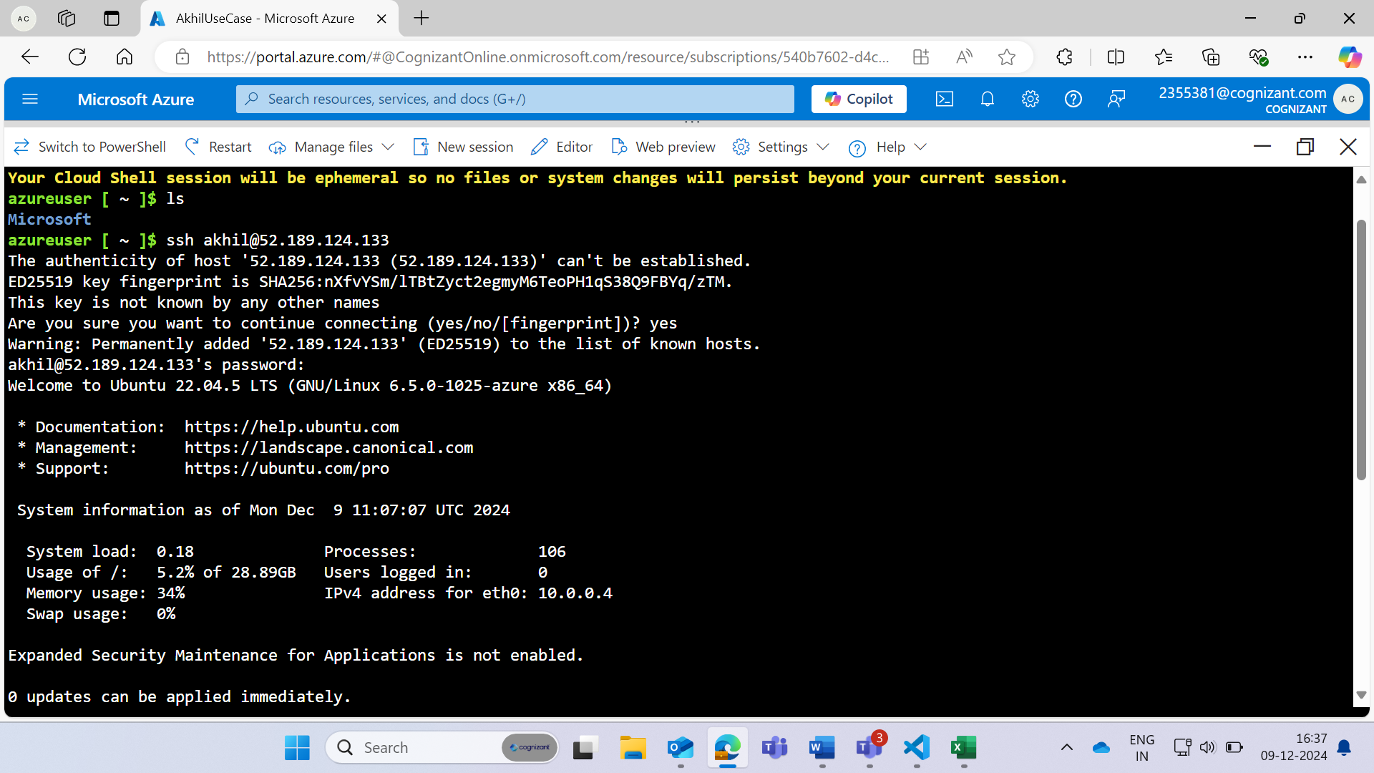

Create the directory **akhilusecase**

Got to **akhilusecase** using **cd akhilusecase**

Create a html file **index.html** and go to Vim editor by using **vim index.html**

**Put your html code in the vim editor:**

**HTML CODE:**

<!DOCTYPE html>

<html lang="en">

<head>

<meta charset="UTF-8">

<meta name="viewport" content="width=device-width, initial-scale=1.0">

<title>Welcome to My World</title>

<style>

body {

font-family: Arial, sans-serif;

background-color:lavender;

color: #333;

margin: 0;

padding: 0;

}

header {

background-color:navy;

color: white;

padding: 1rem;

text-align: center;

}

main {

padding: 2rem;

text-align: center;

}

.section {

margin: 2rem 0;

padding: 1rem;

border-radius: 10px;

}

.btn {

padding: 1rem 2rem;

text-decoration: none;

border-radius: 5px;

font-size: 1.2rem;

margin: 0.5rem;

display: inline-block;

}

.btn-youtube {

background-color: red;

color: white;

}

.btn-resume {

background-color: blue;

color: white;

}

.icon {

width: 24px;

height: 24px;

vertical-align: middle;

}

.coding-section {

background-color: #ffeb3b;

}

.shopping-section {

background-color: #ff9800;

}

.movies-section {

background-color: #8bc34a;

}

.music-section {

background-color: #03a9f4;

}

footer {

background-color: #333;

color: white;

padding: 1rem;

text-align: center;

}

footer a {

color: white;

margin: 0 1rem;

text-decoration: none;

font-size: 1.5rem;

}

footer a:hover {

color: #ddd;

}

</style>

</head>

<body>

<header>

<h1>Hello and Welcome to My World</h1>

</header>

<main>

<div style="color: crimson;"><H1><B style="font-size: large;">Whether you are looking to learn new skills, watch your favorite shows, or create content to share with the world, YouTube provides endless opportunities.</B></H1>

<H2 style="color:peru; font-size: large;"><B>Are you curious about how well your resume performs with Applicant Tracking Systems (ATS)? It's crucial to ensure your resume is ATS-friendly to increase your chances of getting noticed by recruiters. Click the button below to check your resume's ATS score and get helpful tips on improving it.</B></H2>

</div>

<a class="btn btn-youtube" href="https://www.youtube.com" target="_blank">YouTube</a>

<a class="btn btn-resume" href="https://www.resumeworded.com/resume-scanner" target="_blank">Check Resume ATS Score</a>

<div class="section coding-section">

<h2>Coding Resources</h2>

<a class="btn" href="https://www.geeksforgeeks.org" target="_blank">

<img class="icon" src="https://upload.wikimedia.org/wikipedia/commons/4/43/GeeksforGeeks.svg" alt="GeeksforGeeks"> GeeksforGeeks

</a>

<a class="btn" href="https://www.hackerrank.com" target="_blank">

<img class="icon" src="https://hrcdn.net/community-frontend/assets/favicon-ddc852f75a.png" alt="HackerRank"> HackerRank

</a>

<a class="btn" href="https://leetcode.com" target="_blank">

<img class="icon" src="https://upload.wikimedia.org/wikipedia/commons/1/19/LeetCode_logo_black.png" alt="LeetCode"> LeetCode

</a>

</div>

<div class="section shopping-section">

<h2>Shopping</h2>

<a class="btn" href="https://www.amazon.com" target="_blank">

<img class="icon" src="https://upload.wikimedia.org/wikipedia/commons/a/a9/Amazon_logo.svg" alt="Amazon"> Amazon

</a>

<a class="btn" href="https://www.flipkart.com" target="_blank">

<img class="icon" src="https://pluspng.com/img-png/logo-flipkart-png-flipkart-deals-offers-discounts-and-coupons-online-buy-flipkart-products-at-best-prices-in-india-1200.png" alt="Flipkart"> Flipkart

</a>

</div>

<div class="section movies-section">

<h2>Movies</h2>

<a class="btn" href="https://www.jiocinema.com" target="_blank">

<img class="icon" src="https://encrypted-tbn0.gstatic.com/images?q=tbn:ANd9GcRwzbZVqxOx0bH7Ekc7dXNOQ7abnD1d1YCsPnLtCLE&usqp=CAE&s" alt="JioCinema"> JioCinema

</a>

<a class="btn" href="https://www.netflix.com" target="_blank">

<img class="icon" src="https://upload.wikimedia.org/wikipedia/commons/0/08/Netflix_2015_logo.svg" alt="Netflix"> Netflix

</a>

</div>

<div class="section music-section">

<h2>Music</h2>

<a class="btn" href="https://www.spotify.com" target="_blank">

<img class="icon" src="https://upload.wikimedia.org/wikipedia/commons/1/19/Spotify_logo_without_text.svg" alt="Spotify"> Spotify

</a>

</div>

</main>

<footer>

<a href="https://www.linkedin.com/in/akhilesh-chauhan-140274245" target="_blank">

<img src="https://img.icons8.com/ios-filled/50/ffffff/linkedin.png" alt="LinkedIn">

</a>

<a href="https://github.com/AkhileshChauhan007" target="_blank">

<img src="https://img.icons8.com/ios-filled/50/ffffff/github.png" alt="GitHub">

</a>

</footer>

</body>

</html>

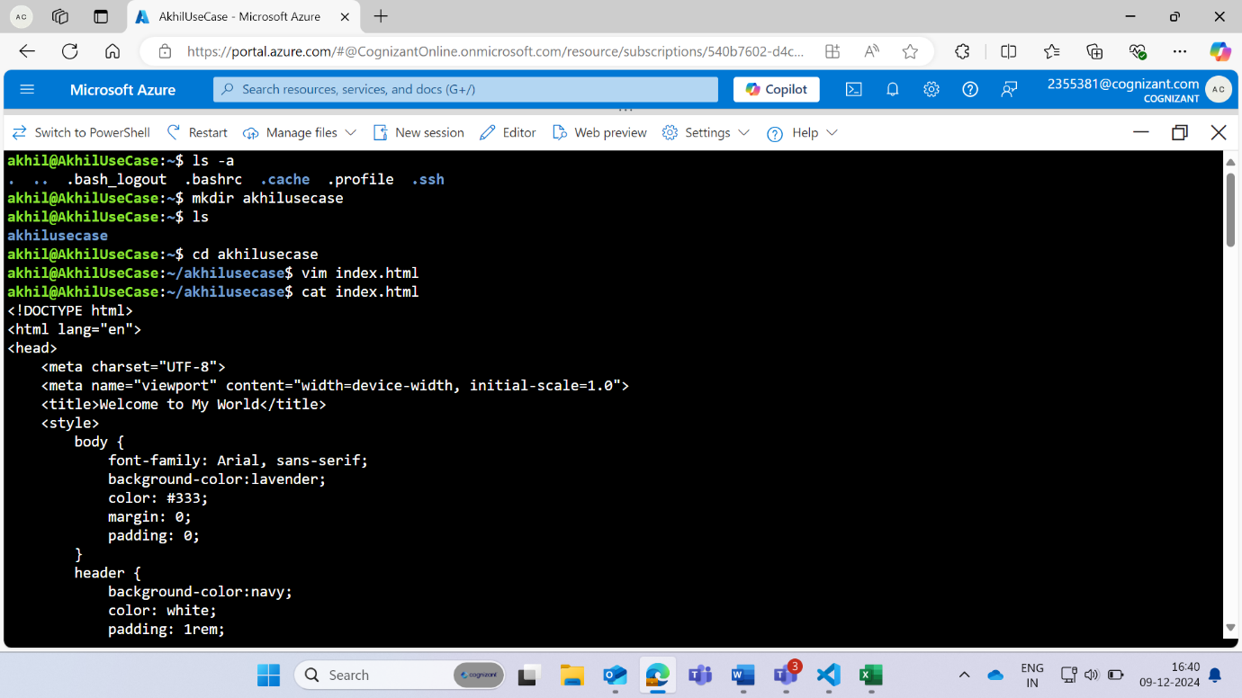

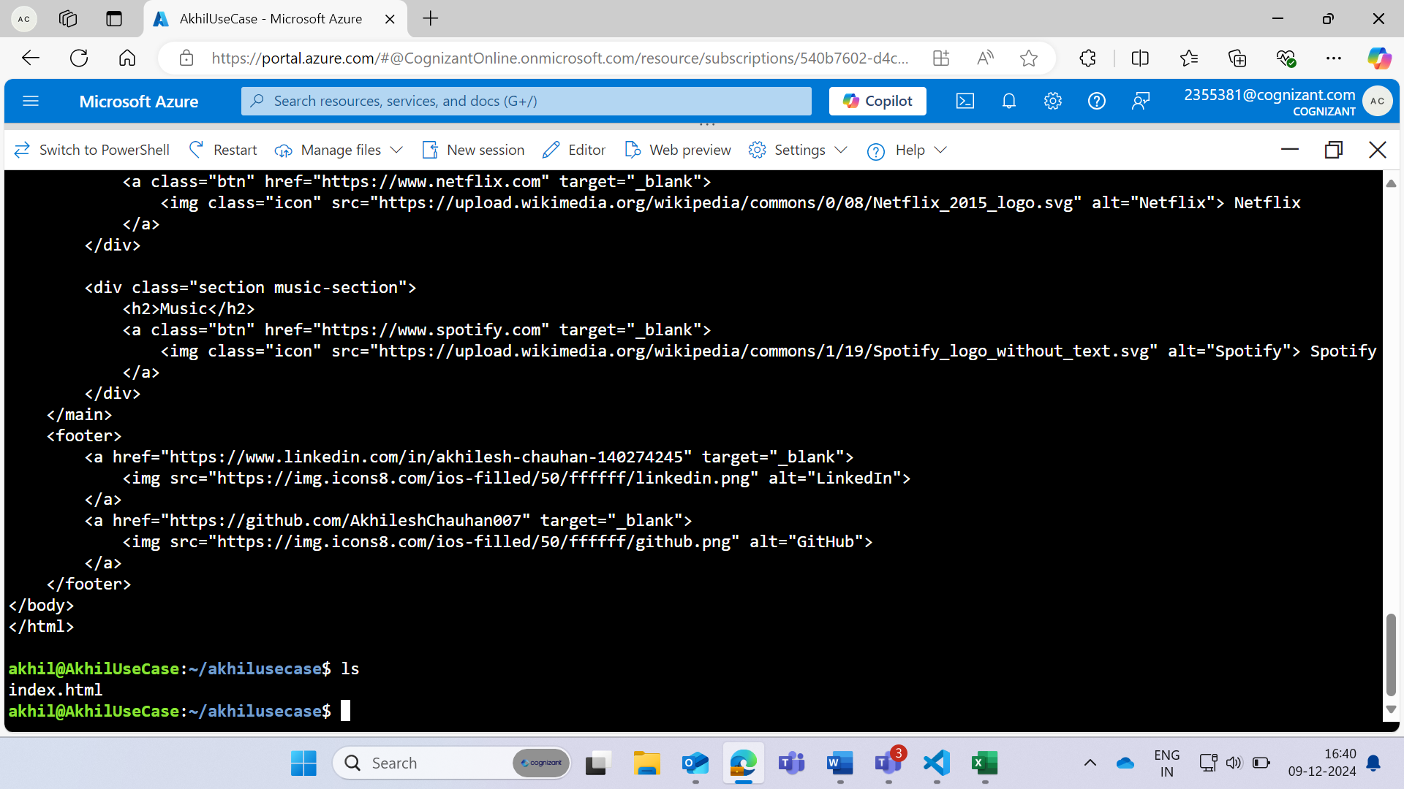

**Create the dockerfile and open it in the vi editor**

**Dockerfile Code:**

# Use the official Nginx image as a base  
**FROM nginx:latest**

# Copy the custom index.html to the default Nginx html directory  
**COPY index.html /usr/share/nginx/html/index.html**

# Expose port 80 to the outside world  
**EXPOSE 80**

# Start Nginx when the container launches  
**CMD ["nginx", "-g", "daemon off;"]**

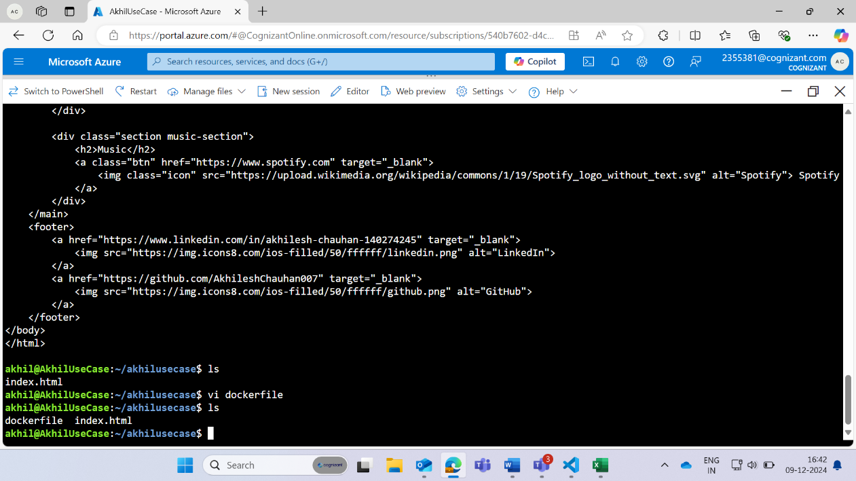

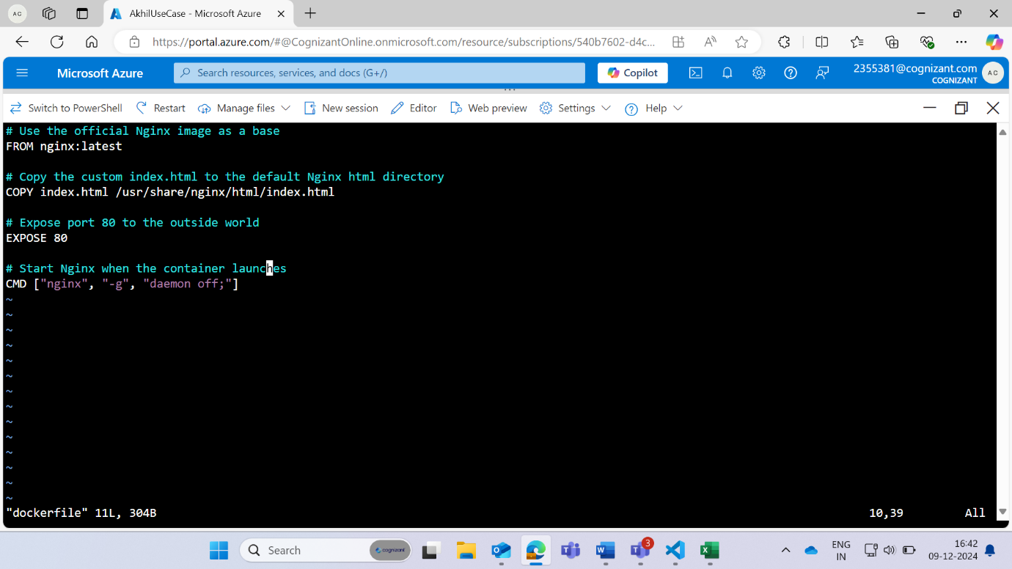

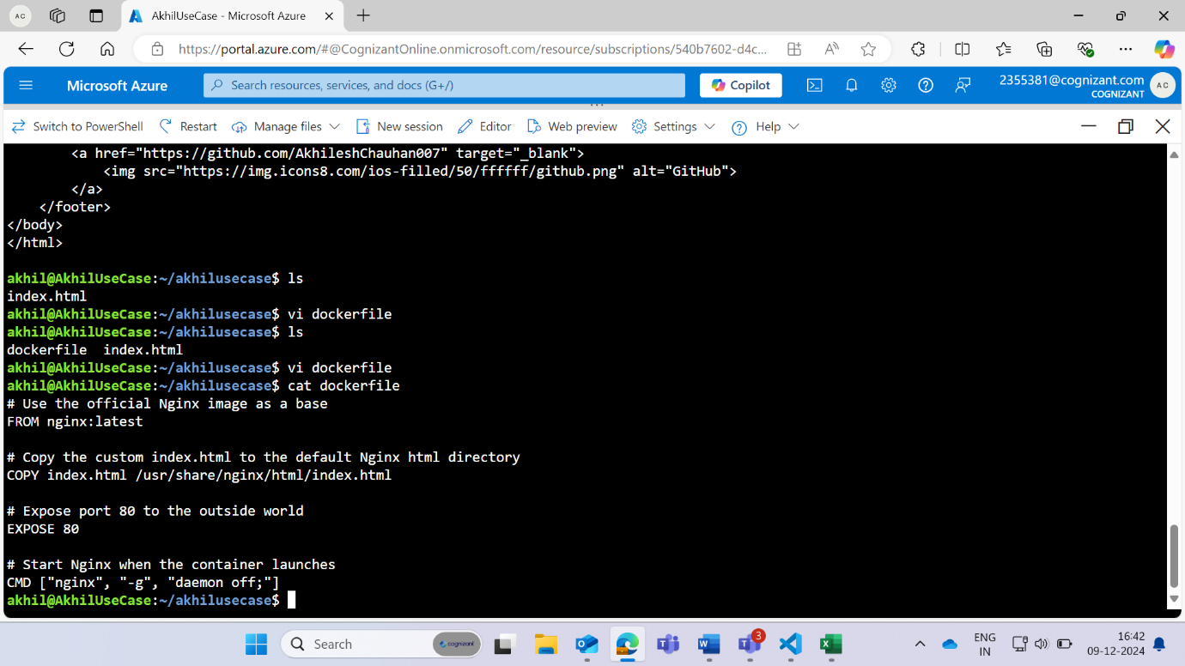

**Open DockerHub and create repository**

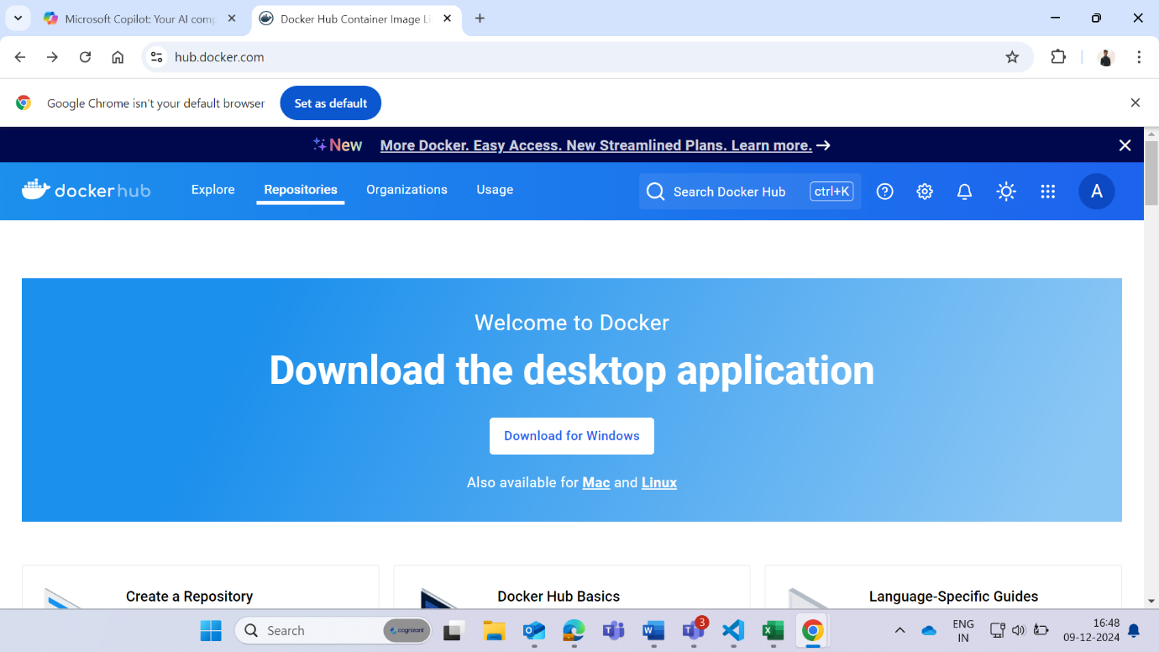

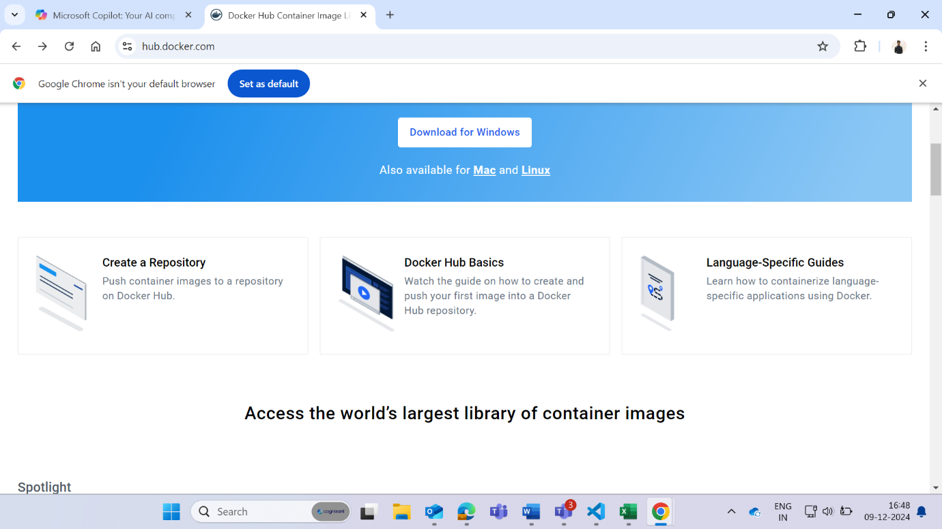

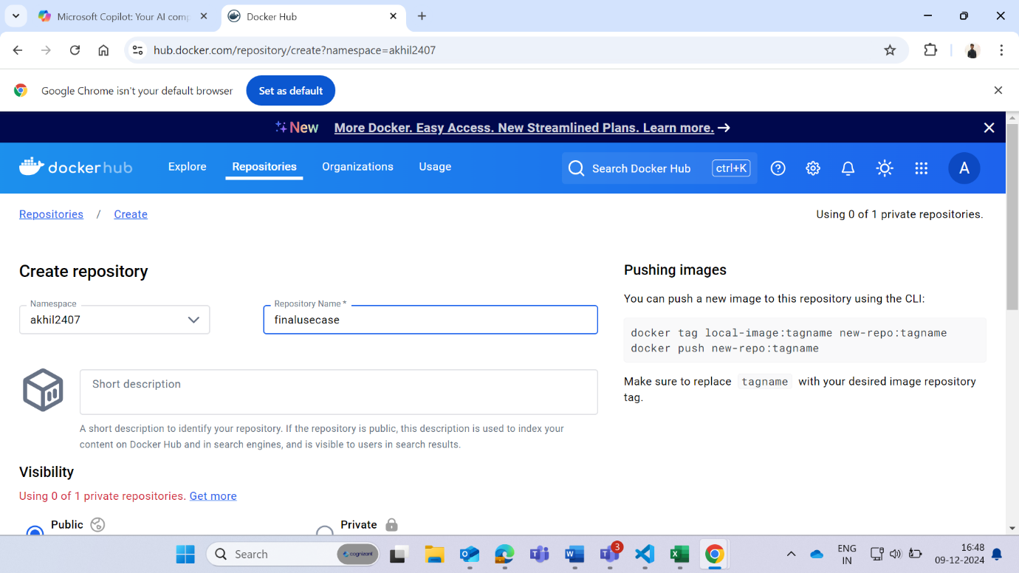

**Update and install docker**

- Sudo apt update

- Sudo apt install docker.io

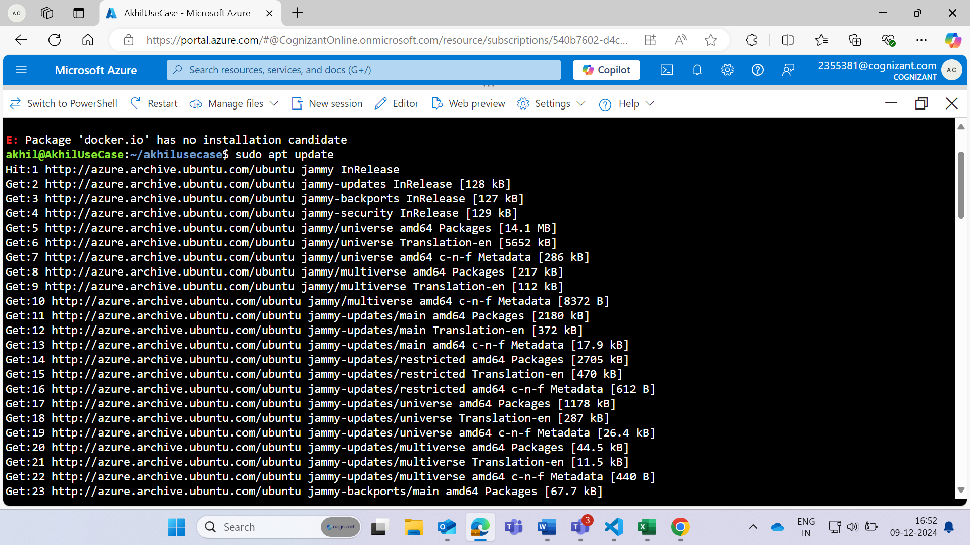

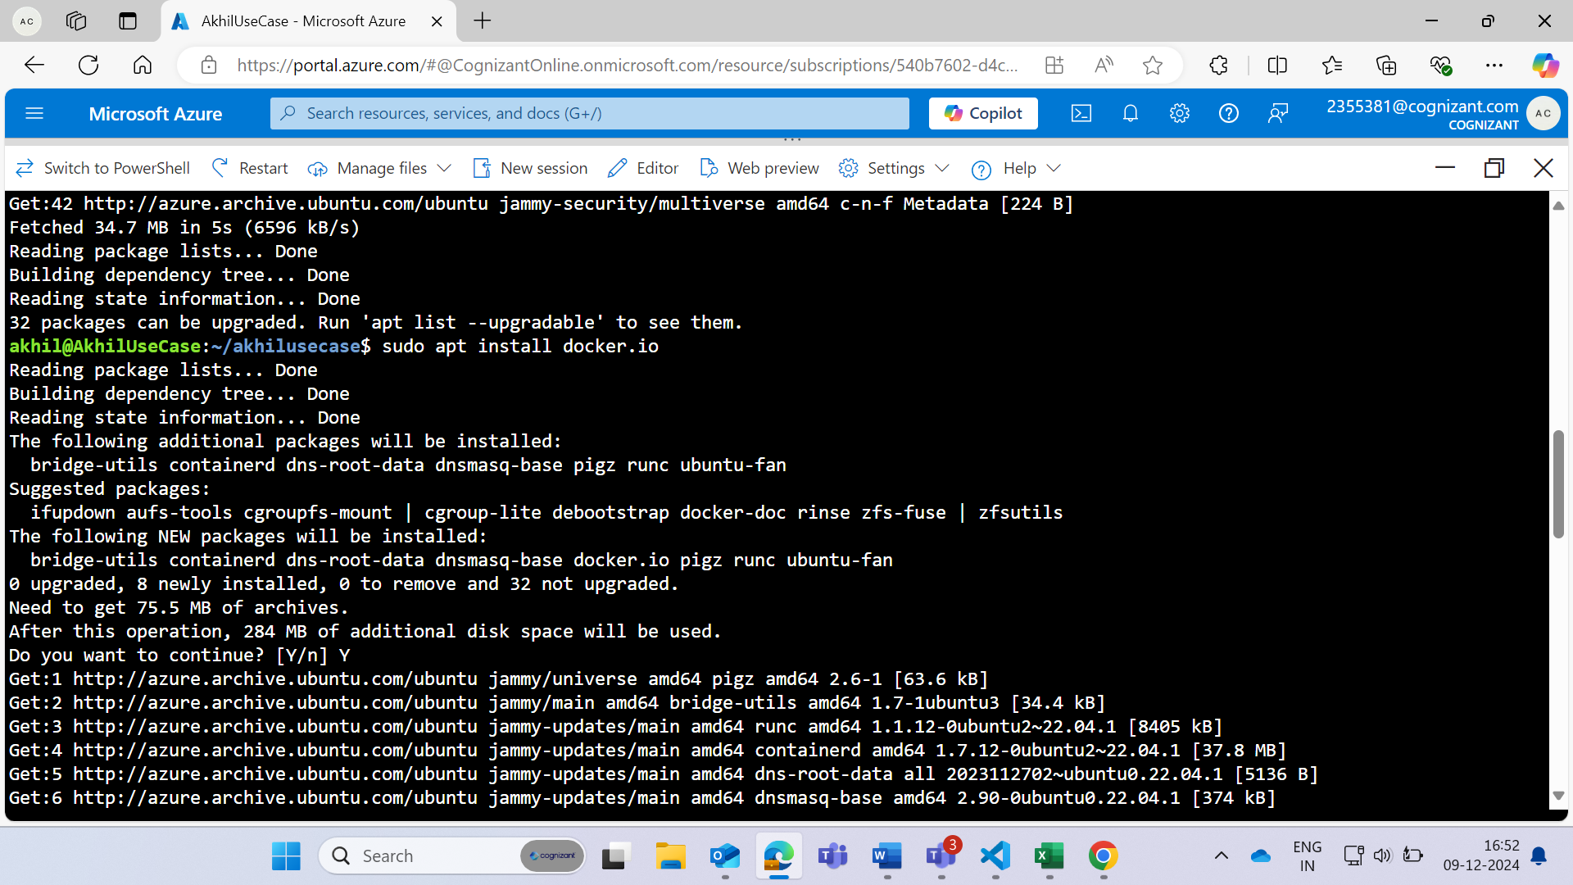

**Buid the docker image which is being created in the docker repository**

**sudo docker build -t (repo_name):latest .**

if it doesn’t work then use **ls** and check the name of **dockerfile** and rename it with **Dockerfile** using **mv dockerfile Dockerfile**.

**Docker login**

**Sudo docker push (image_name):tag_name**

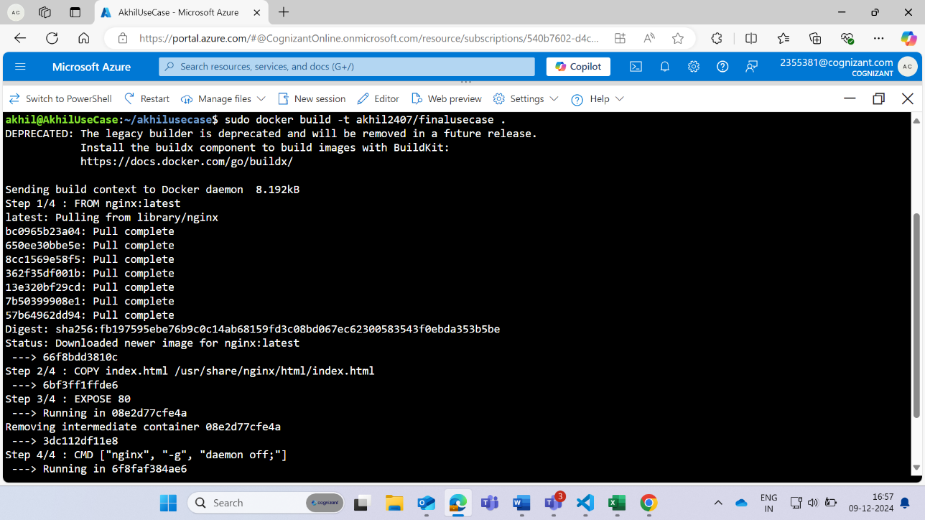

**Image is Created in docker repository**

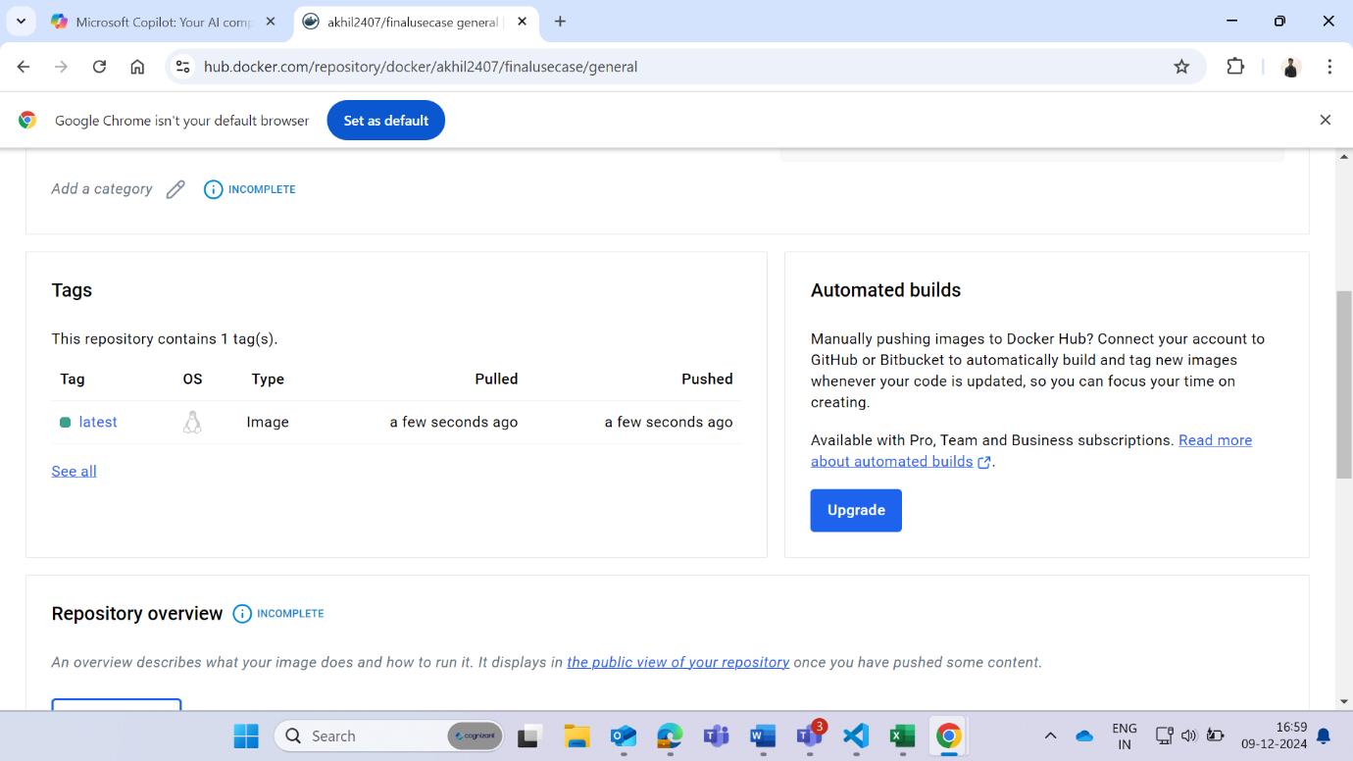

**Create a Kubernetes cluster**

Select the resource group

Select Cluster preset configuration to **DEV/TEST**

Select the zones

disable recommended alert rules in the monitoring section

Then create the Kubernetes cluster

**Step 1:**

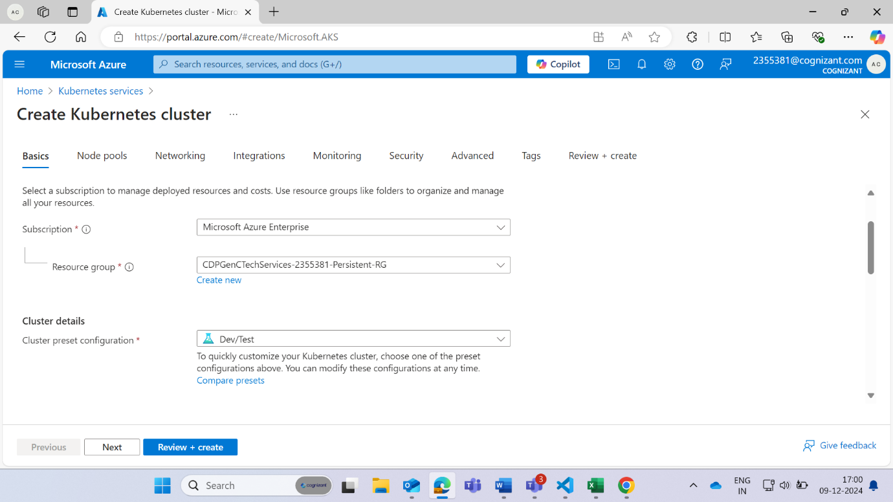

**Step 2:**

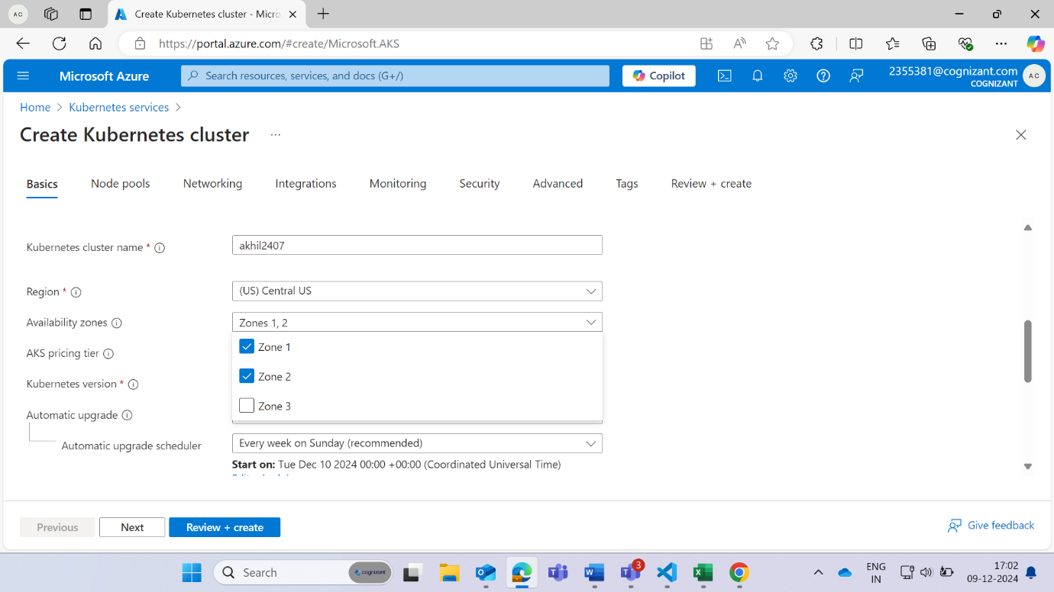

**Step 3:**

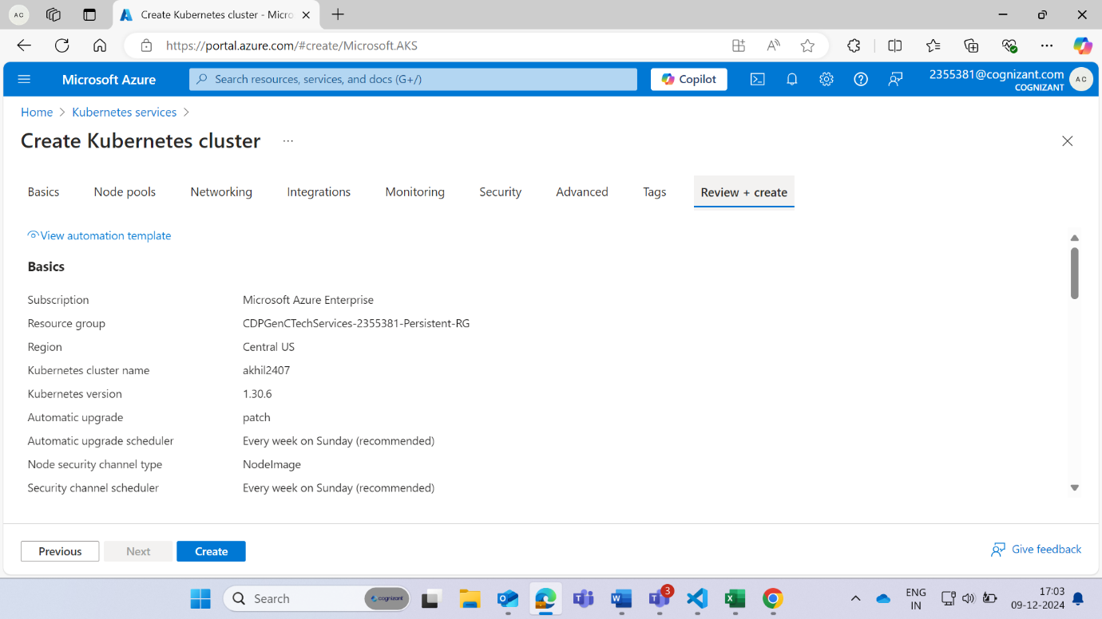

**Step 4:**

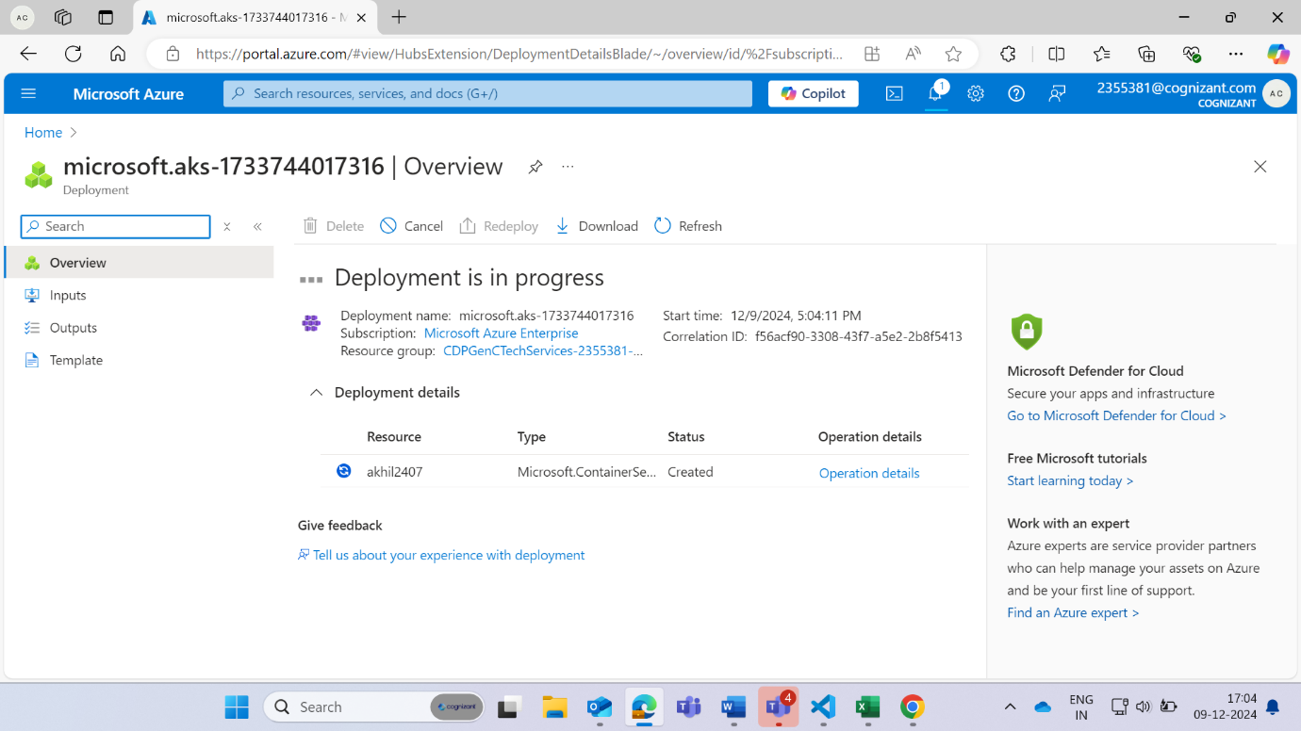

**Step 5:**

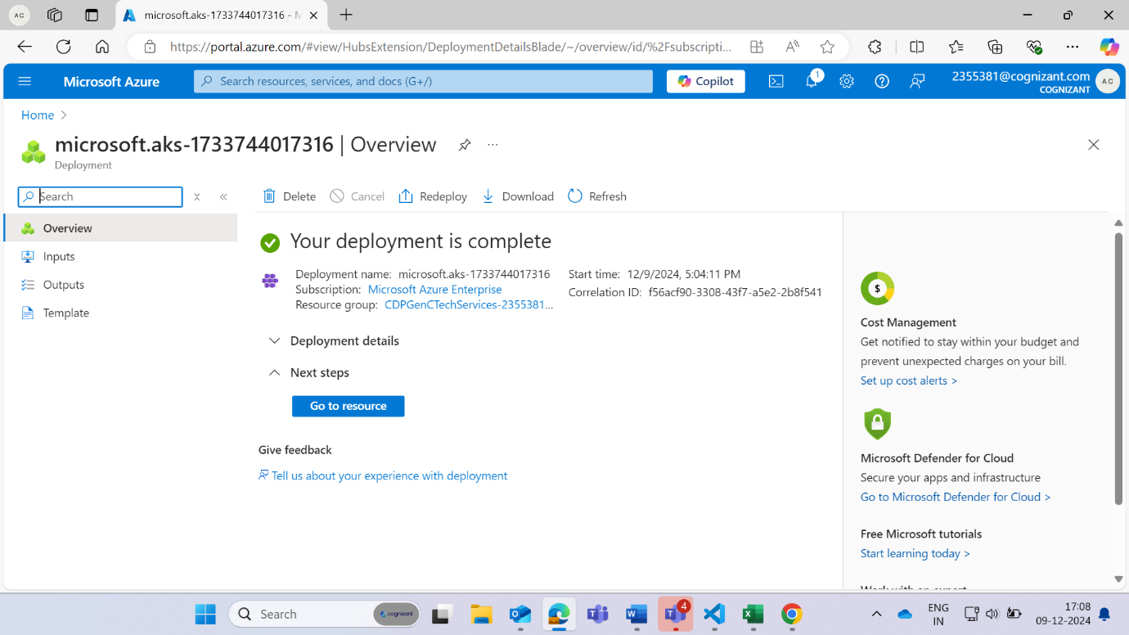

**Step 6:**

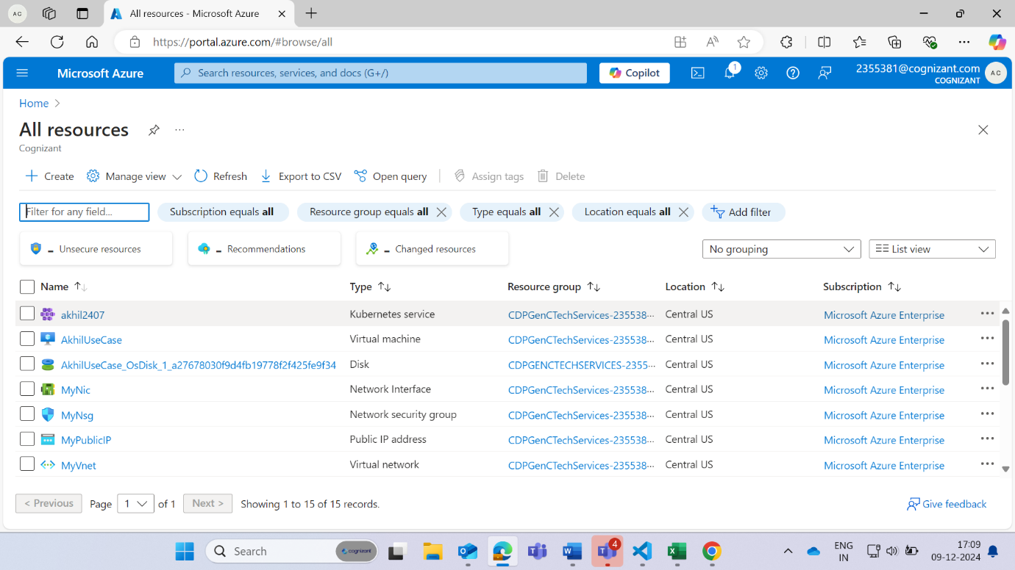

**Step 7:**

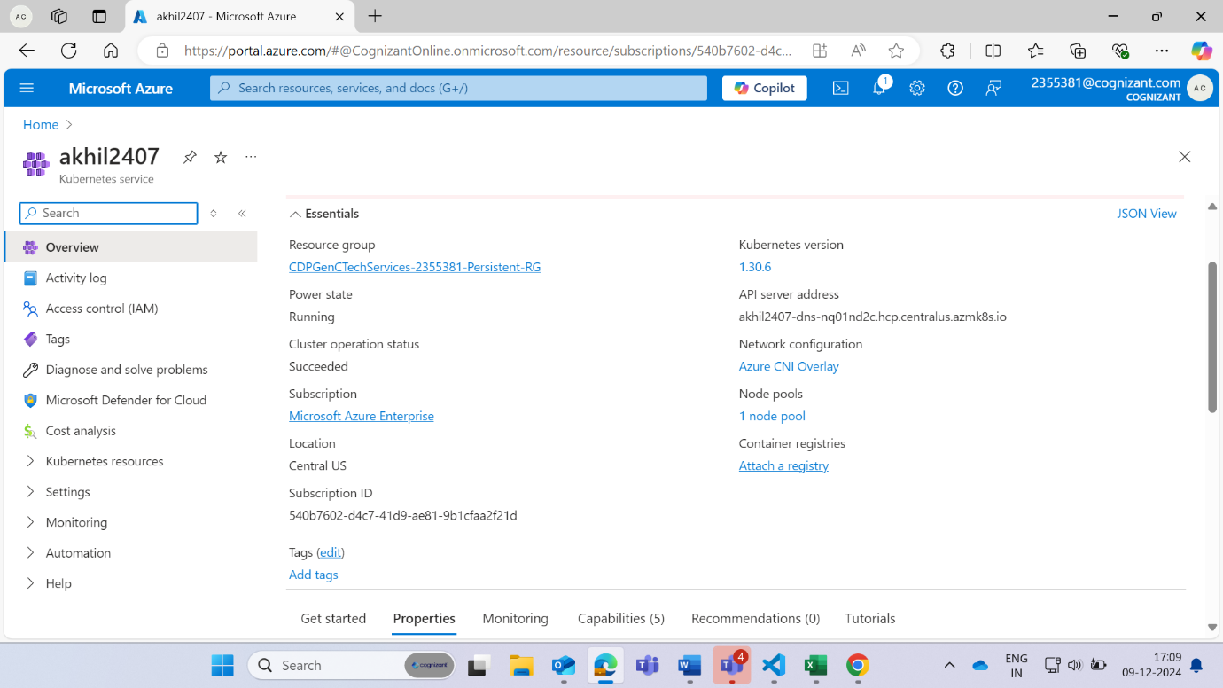

**Create the deployment.yaml file in Kubernetes cluster itself by opening the cloud shell inside the Kubernetes by clicking to the connect button and open it in the vi editor**

apiVersion: apps/v1  
kind: Deployment  
metadata:  
  name: my-deployment  
spec:  
  replicas: 3  
  selector:  
    matchLabels:  
      app: my-app  
  template:  
    metadata:  
      labels:  
        app: my-app  
    spec:  
      containers:  
      - name: my-container  
        image: akhil2407/finalusecase:latest  
        ports:  
        - containerPort: 80

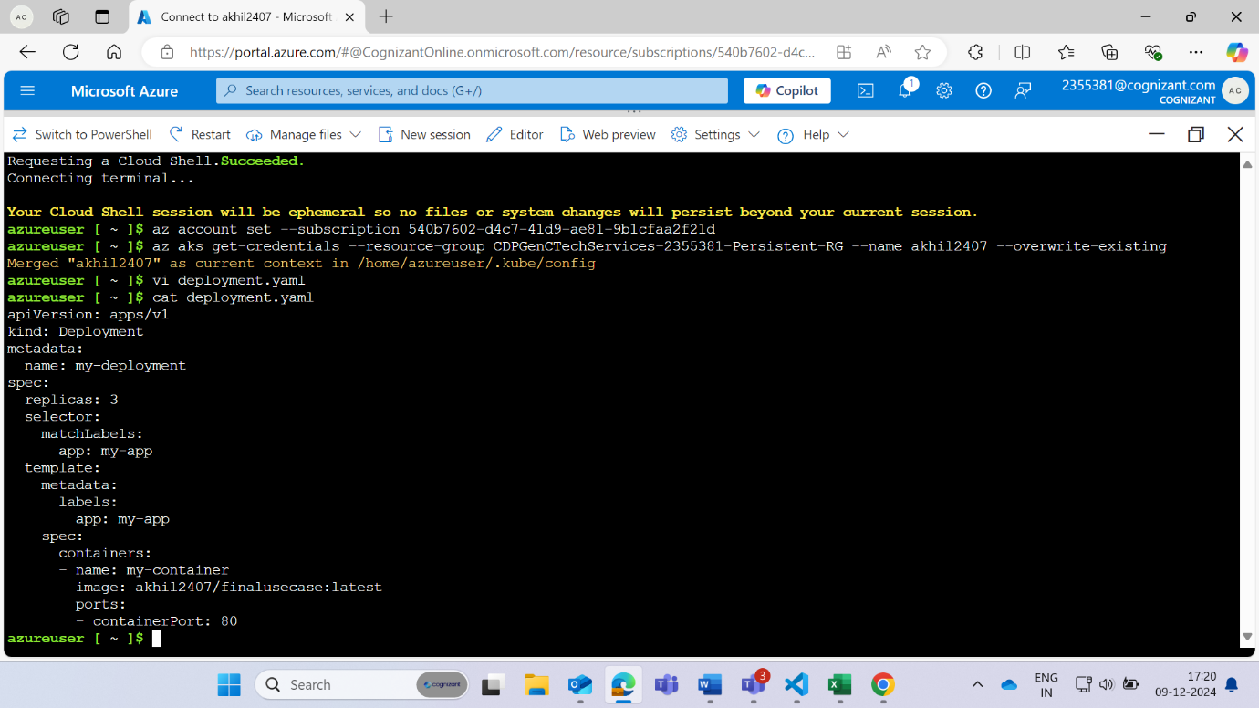

**Create the service.yaml file and open it in the vi editor**

apiVersion: v1  
kind: Service  
metadata:  
  name: my-service  
spec:  
  selector:  
    app: my-app  
  ports:  
    - protocol: TCP  
      port: 80  
      targetPort: 80  
  type: LoadBalancer

**Use the Following command to apply and check the script:**

To Run the below command go to Kubernetes cluster click on connect then click to open with cloud shell

**Run the deployment file:** Kubectl apply -f deployment.yaml

**Check the deployment file:** kubectl get deployment

**Run the service file:** Kubectl apply -f service.yaml

**Check the service file:** kubectl get service

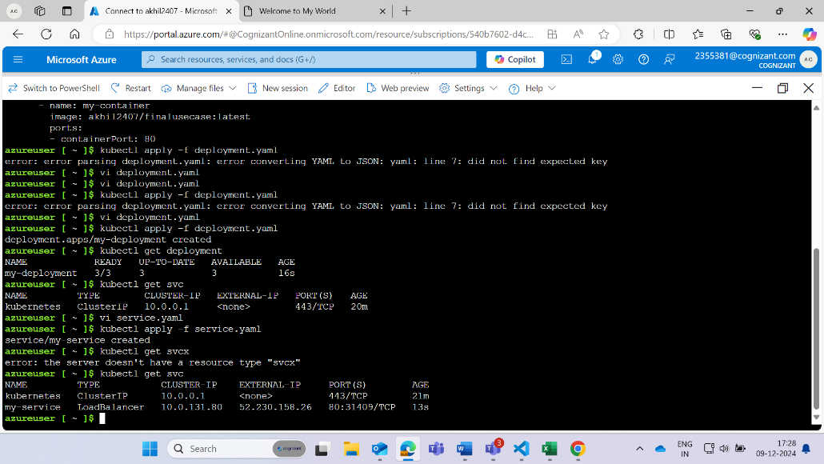

Use the above External IP i.e **52.230.158.26** to run on the search engin usnig the port **80**

Search **52.230.158.26:80** you will get the below output.

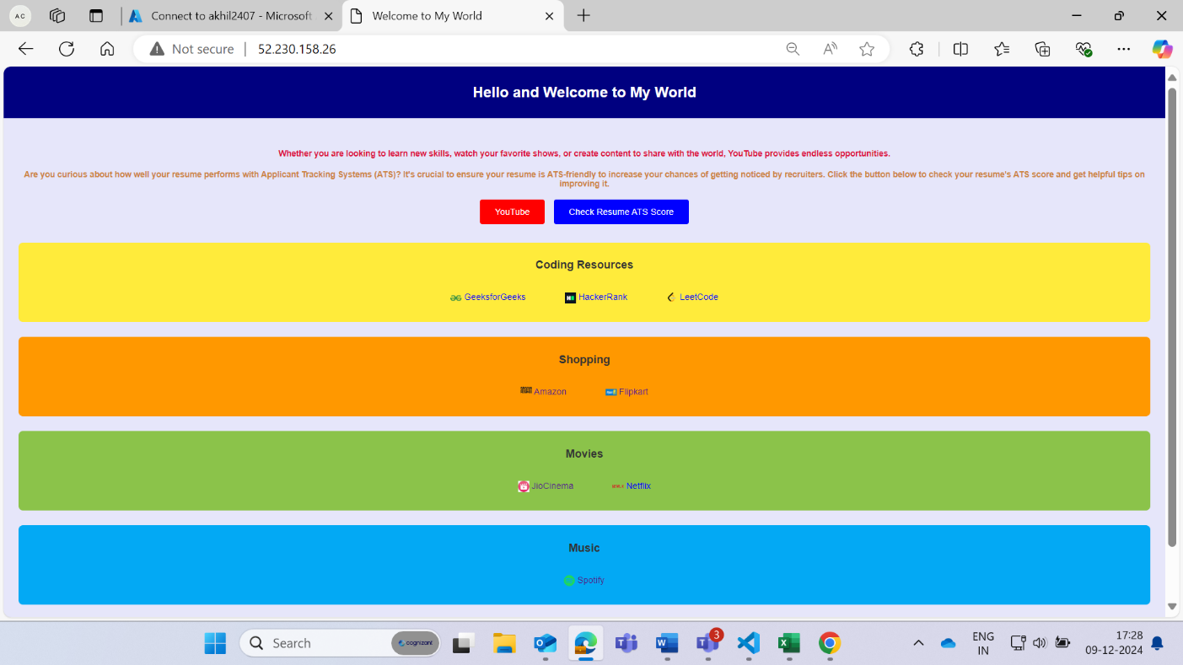

**The CI/CD flow Chart**

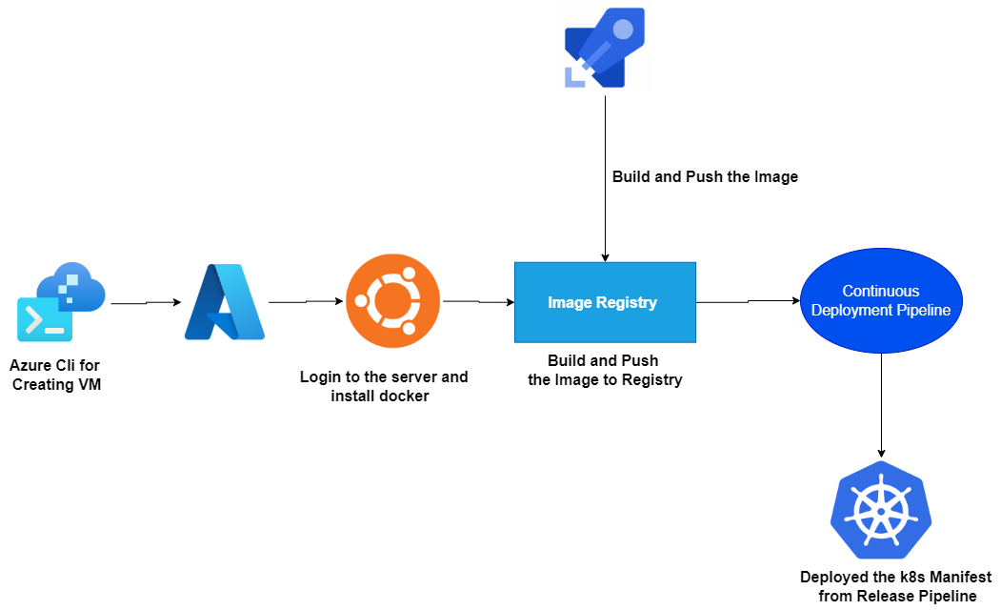

**Step 1:** Open Azure Devops in another Tab

**Step 2:** Use virtual machine CLI

**Step 3:** Now bring the azure repository in the virtual machine

**Step 4:** Command: **git clone (link provided in the azure git repository)**

**Step 5:** put the credential from the azure repository

**Step 6:** now go to vm cli and move all the index.html, deployment.yaml, service.yaml to the azure repo which is begin cloned in the virtual machine.

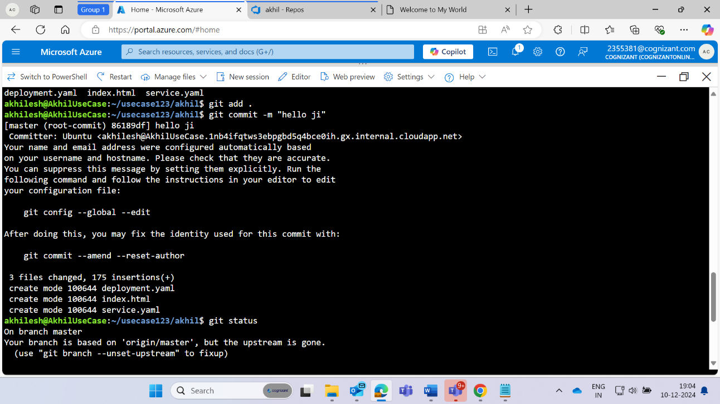

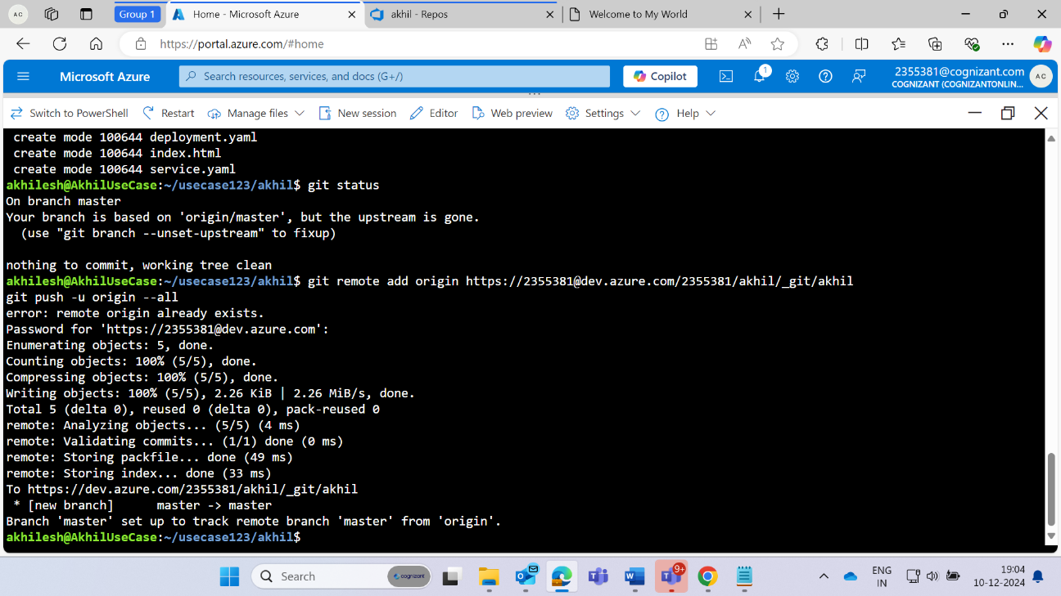

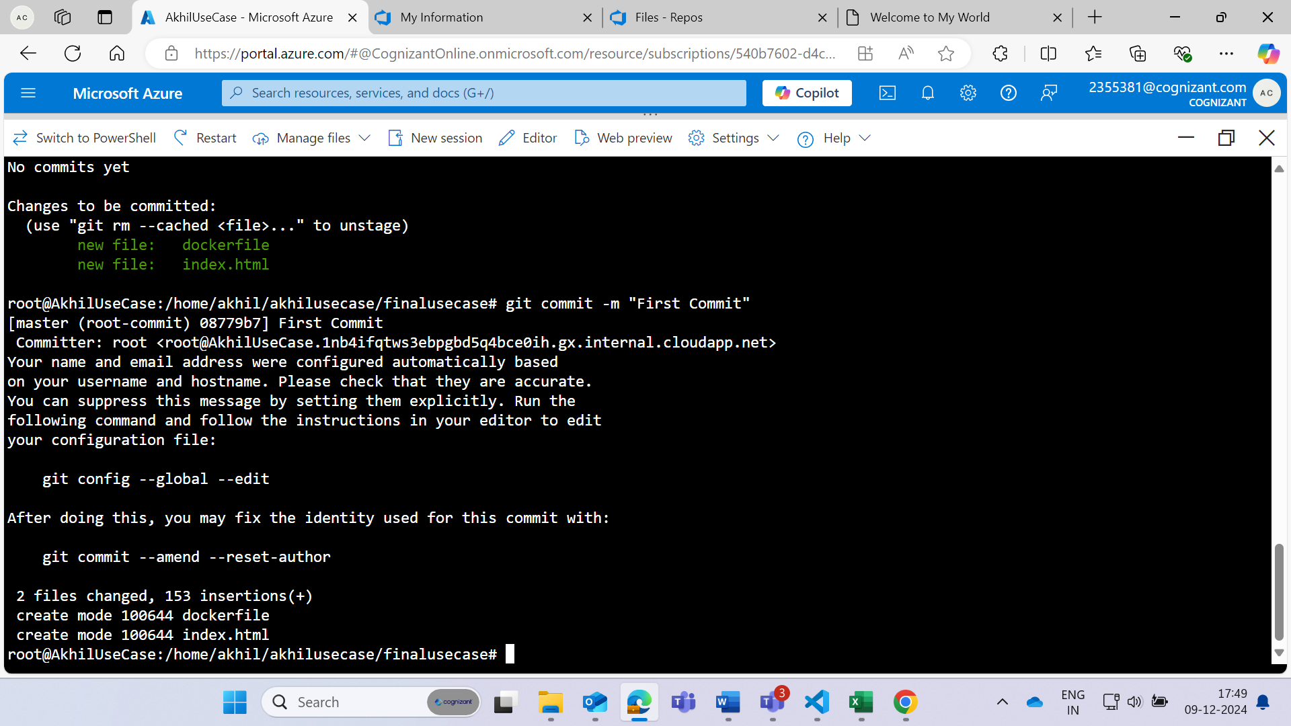

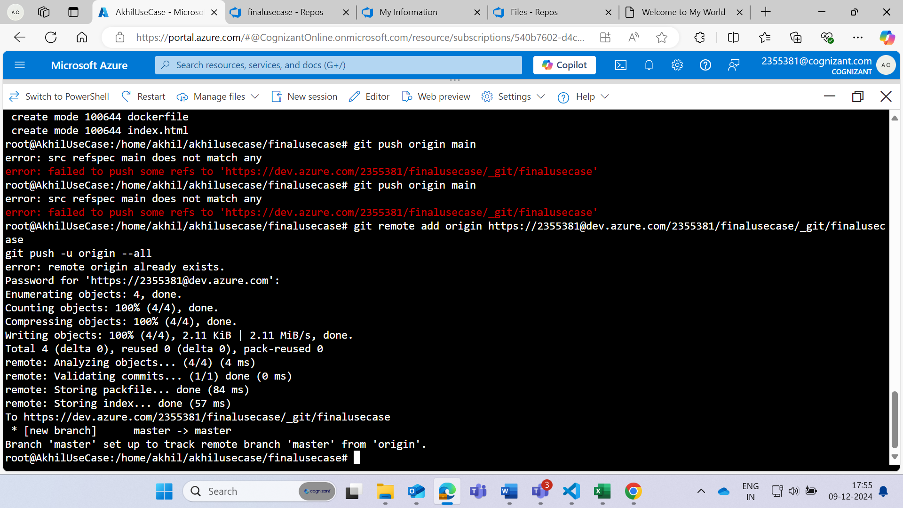

**This is the file which is pushed in the Azure repository.**

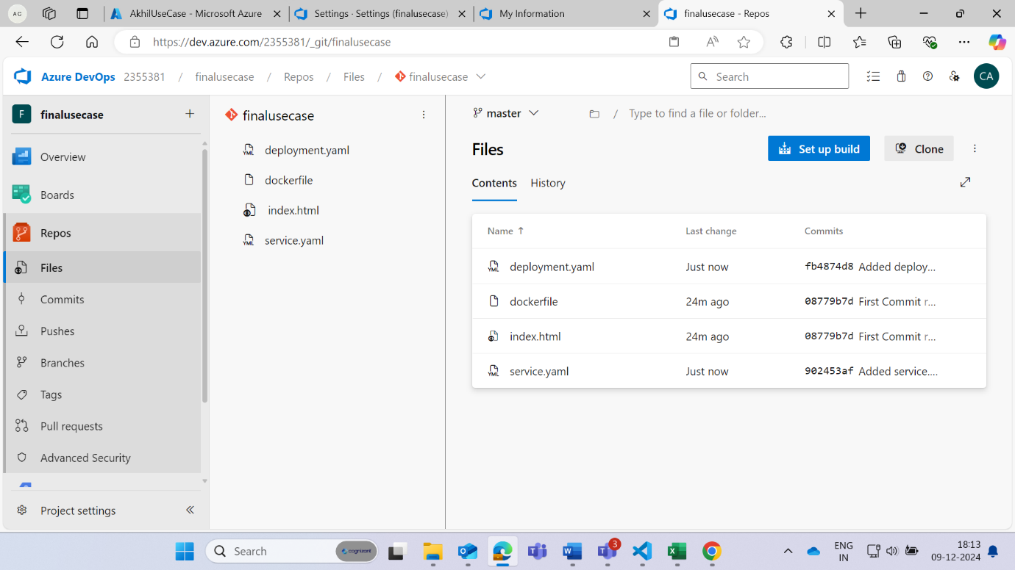

**Open the Azure Pipeline**

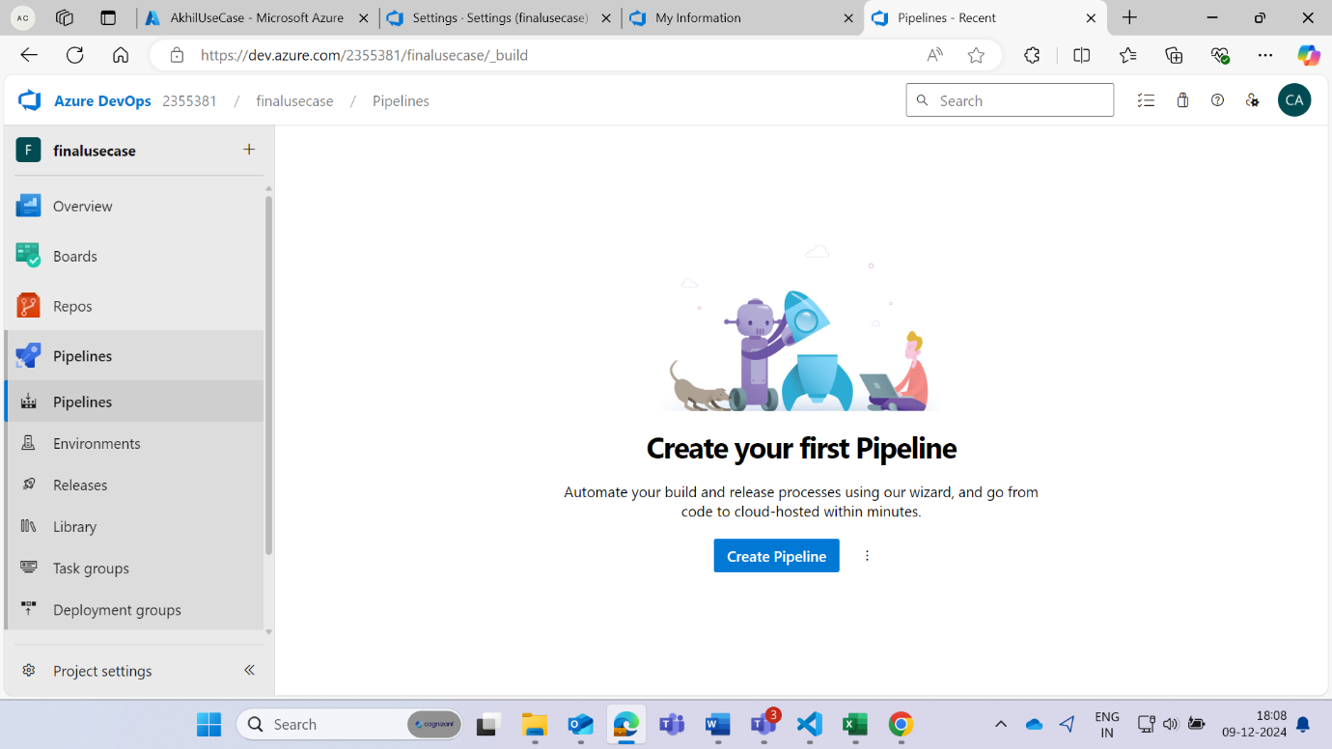

**Select (use the classic editor to create pipeline)**

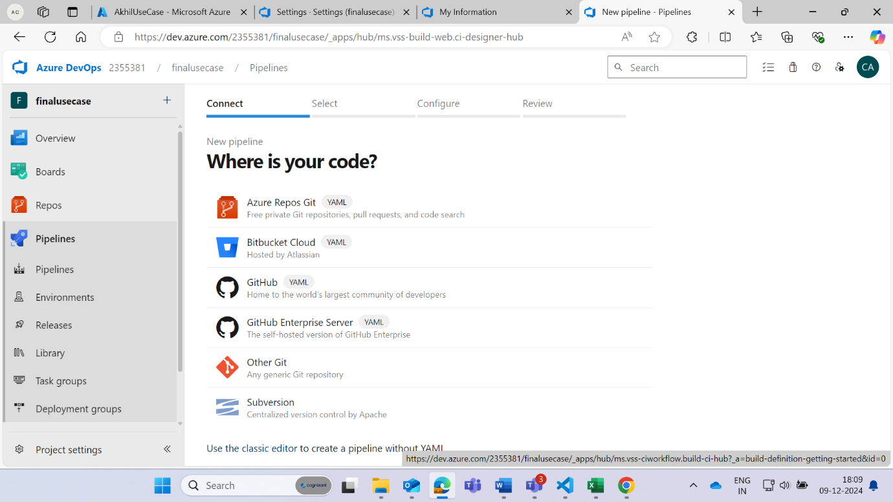

**Select the Azure Devops**

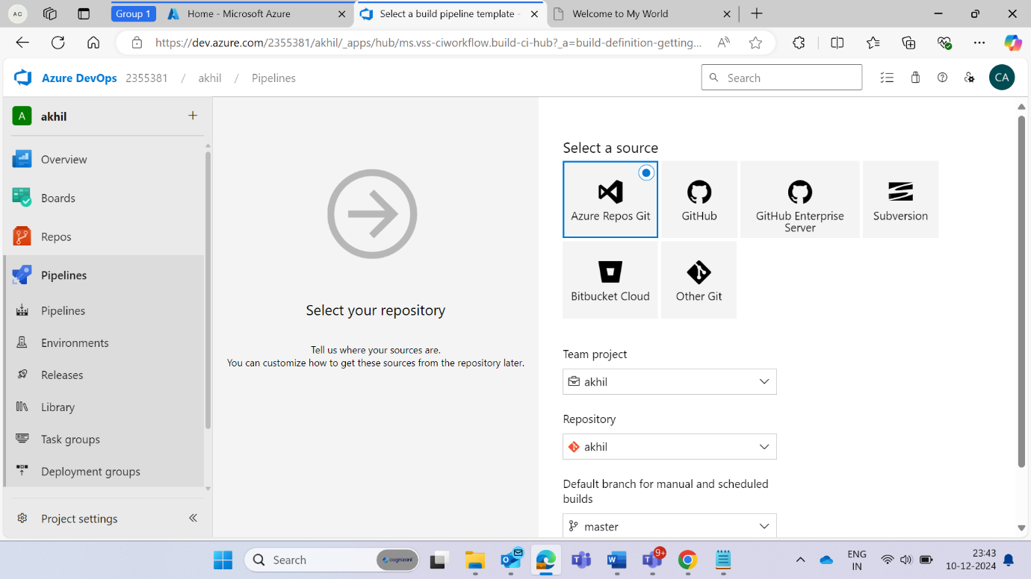

**Click on Empty Job**

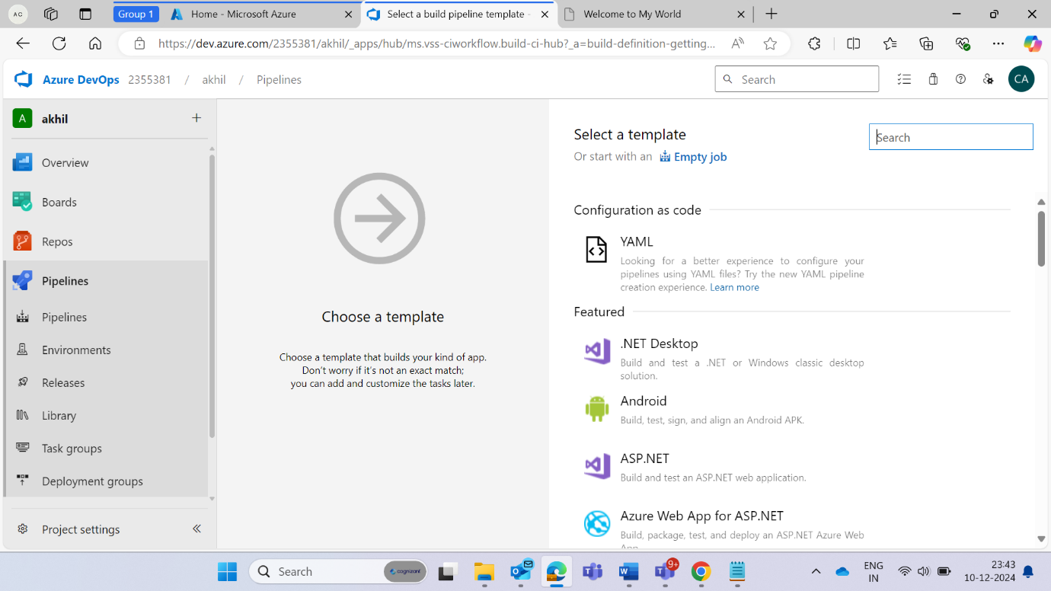

**Now the pipeline portal will open.**

Select Agent specification = ubuntu-22.04

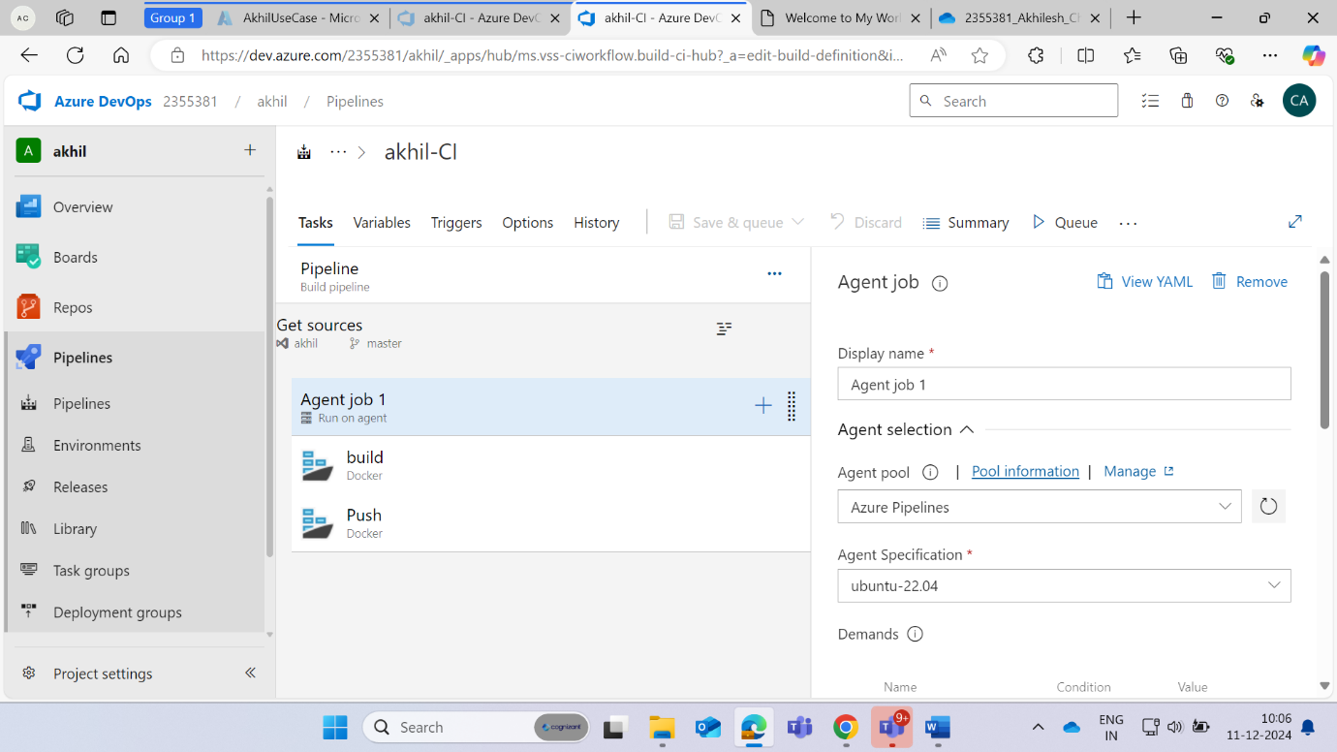

**Select the DockerHub and give the credentials and verify**

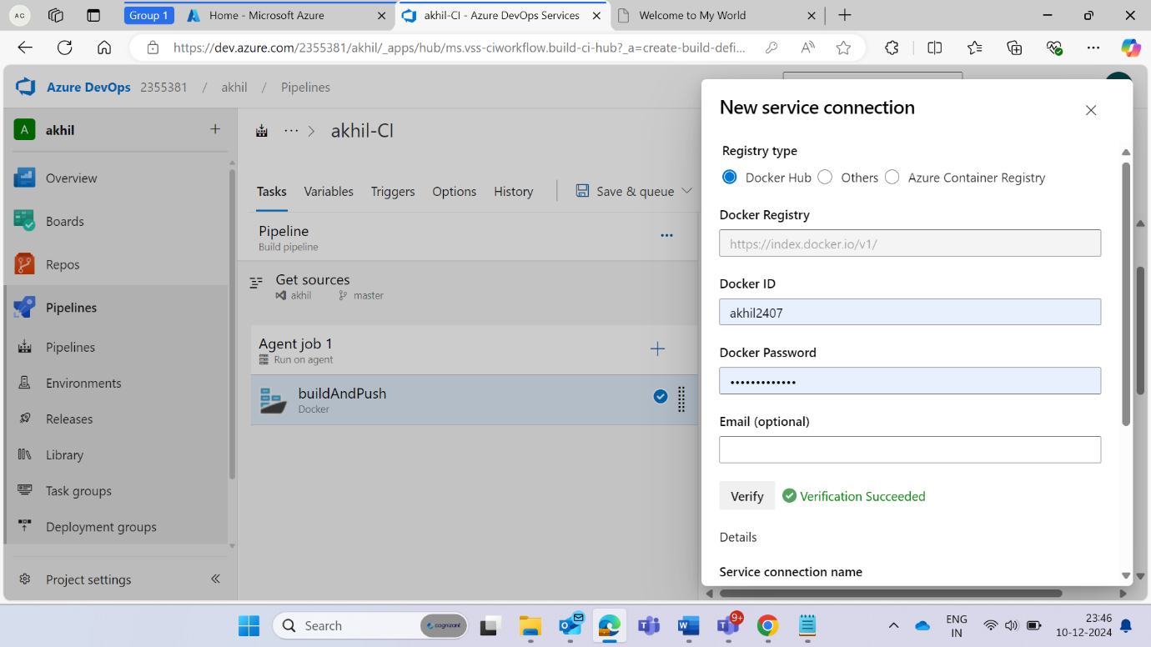

**Now fill the information for the docker build**

Fill the name section, give the tag as latest

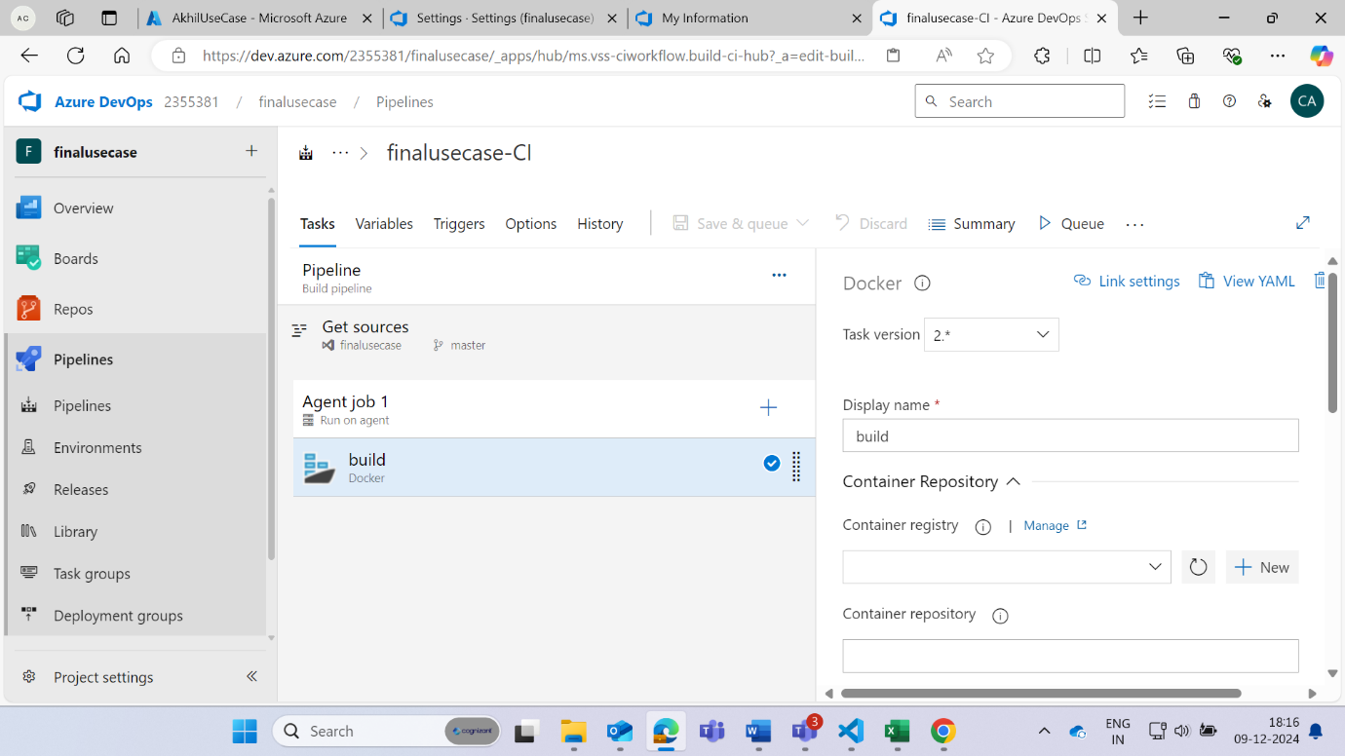

**Container repository = DockerHub repository name**

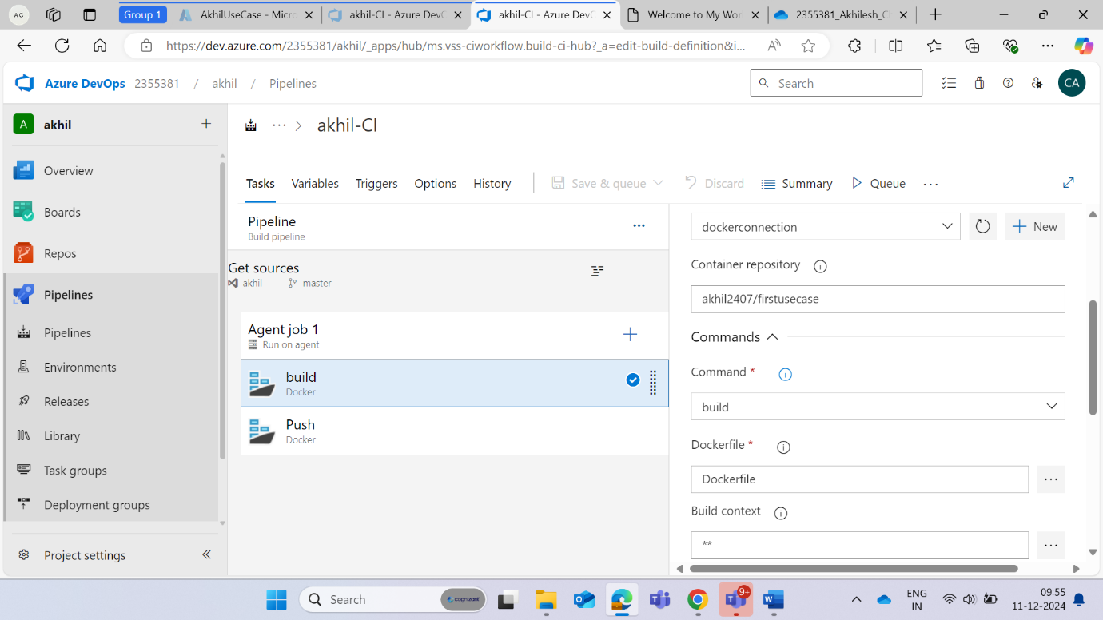

**Create the docker push in the same steps we followed to create the docker build**

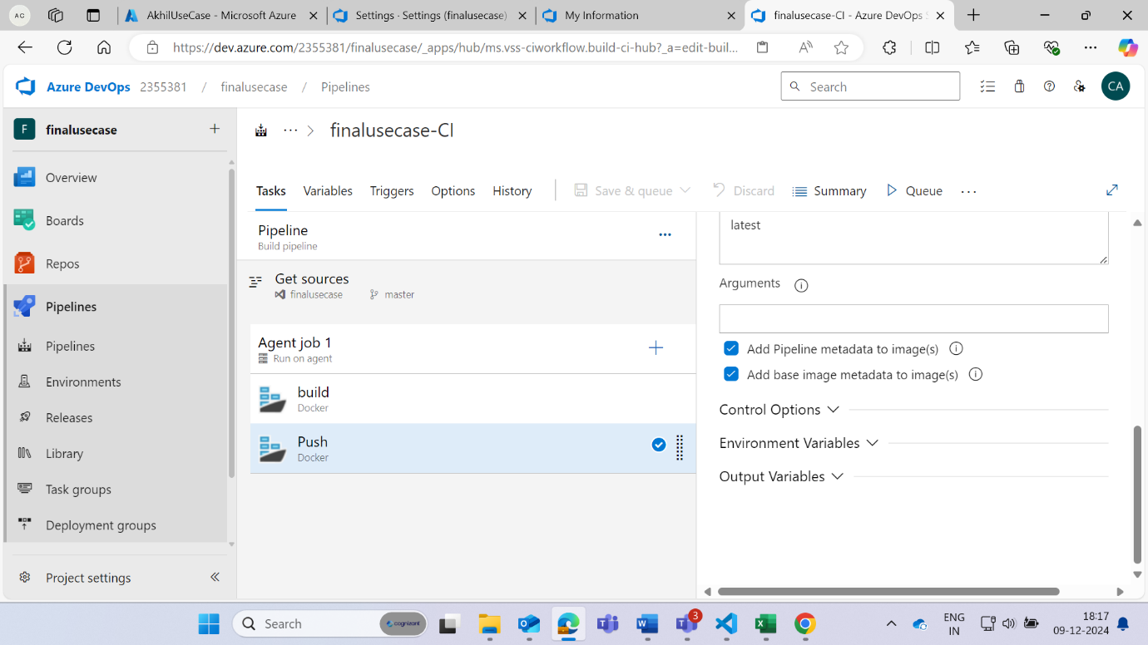

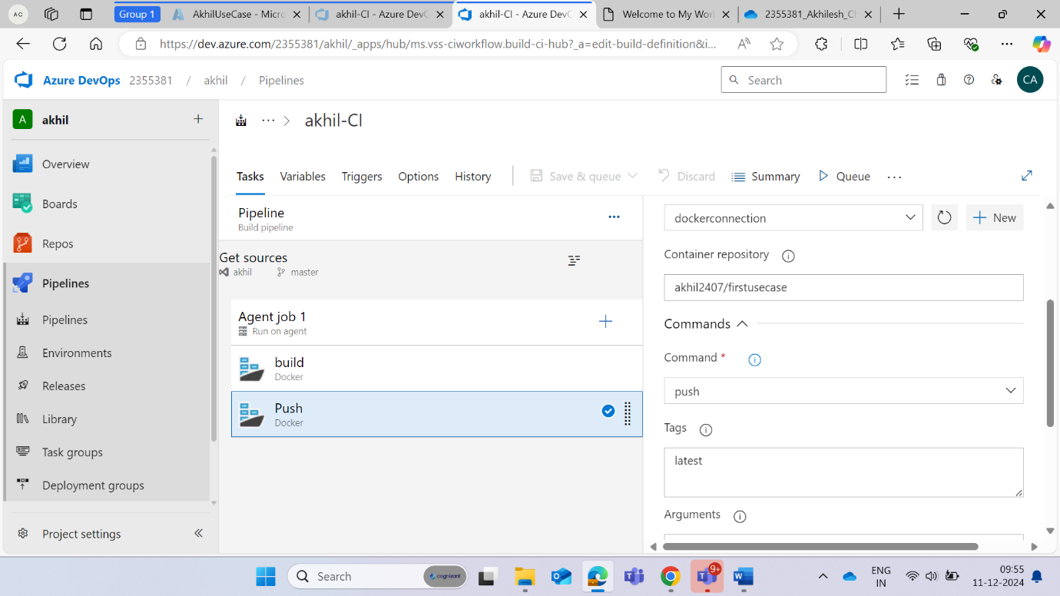

**Run the queue**

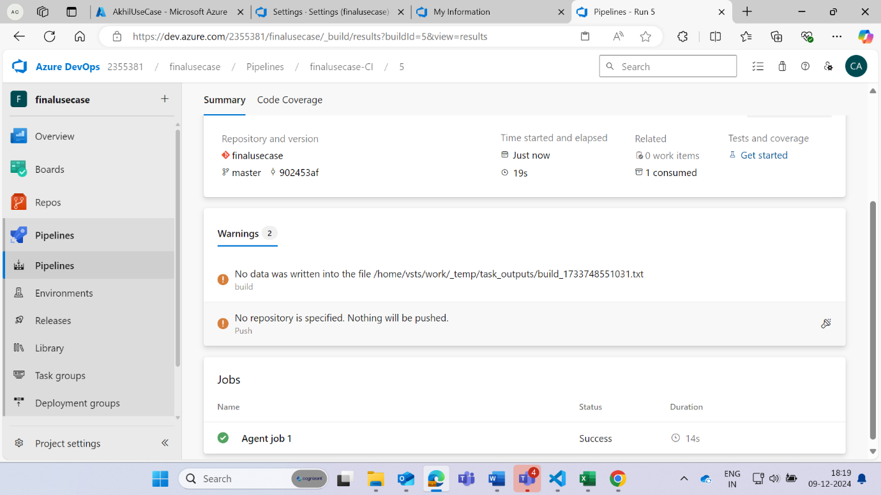

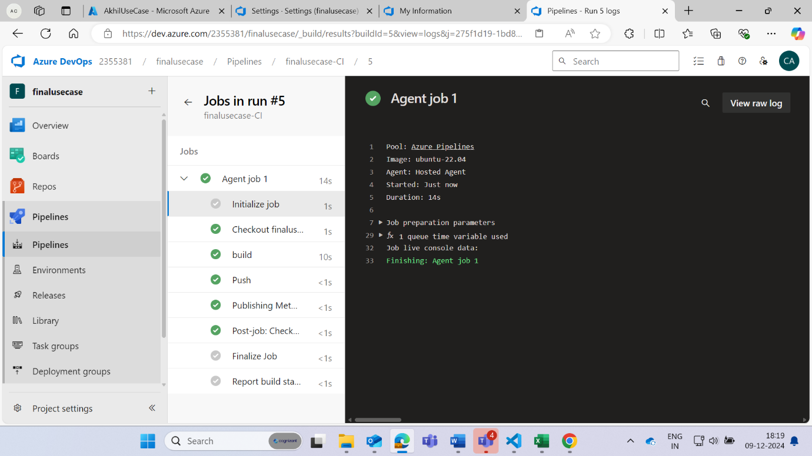

**Go to Releases option in the pipeline**

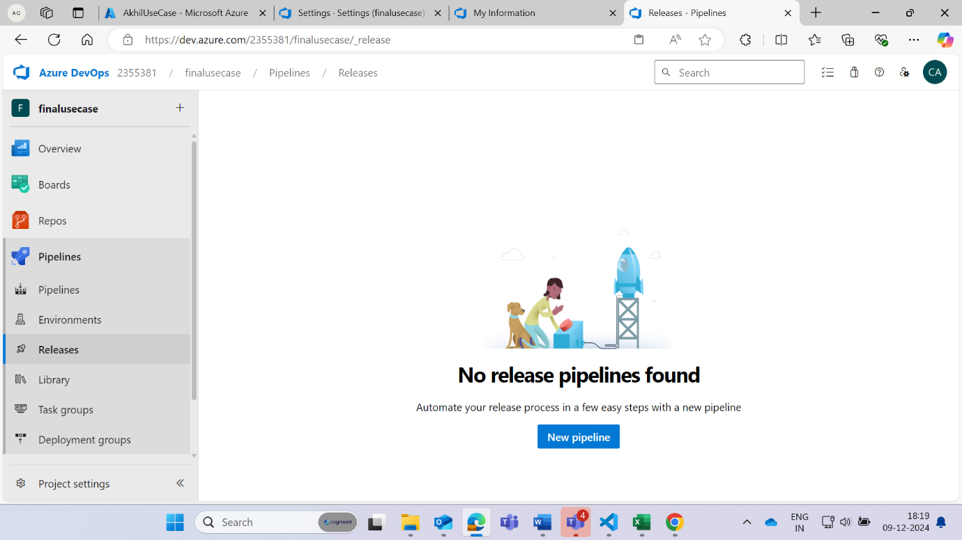

**Add Azure Build**

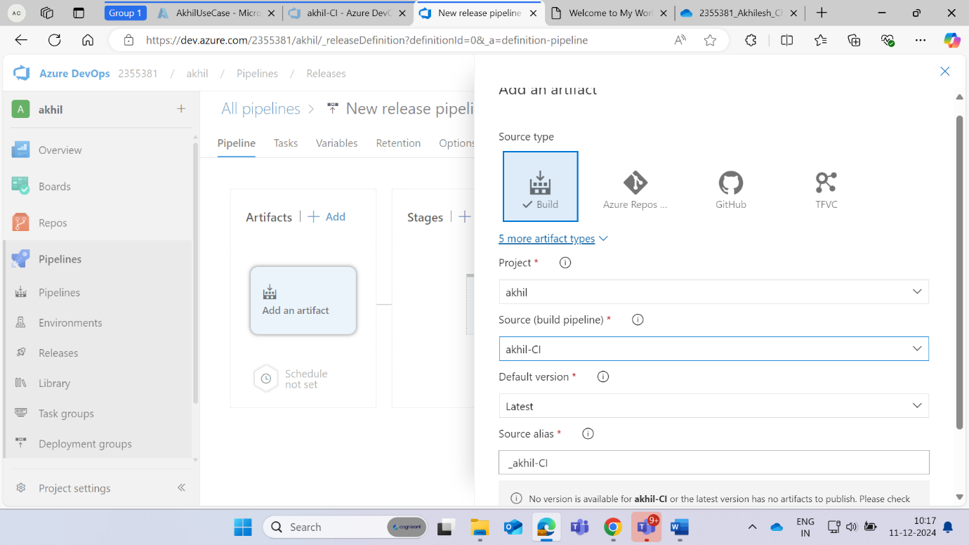

**Add Azure Repo**

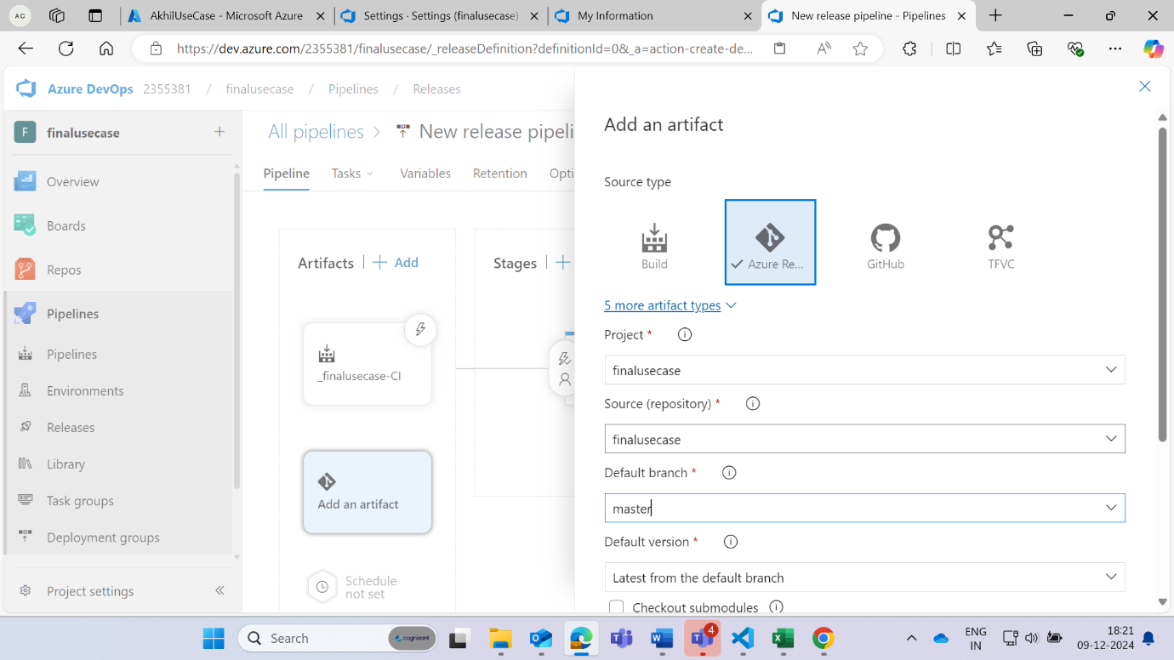

**Enable the continuous Deployment**

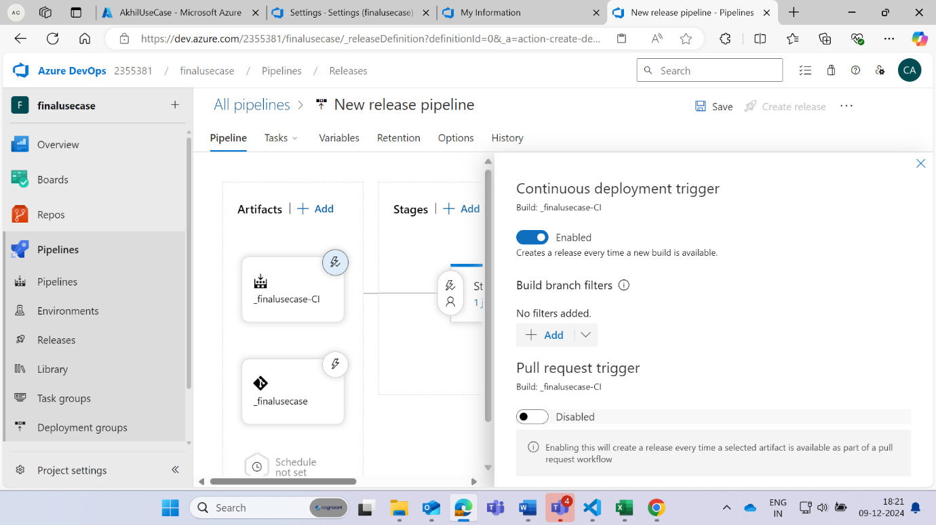

**Go to the task to add Kubernetes deployment and service**

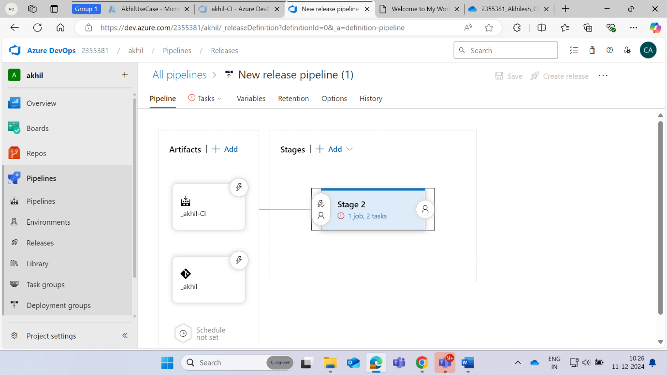

**Search deployment to Kubernetes for the Service and deployment**

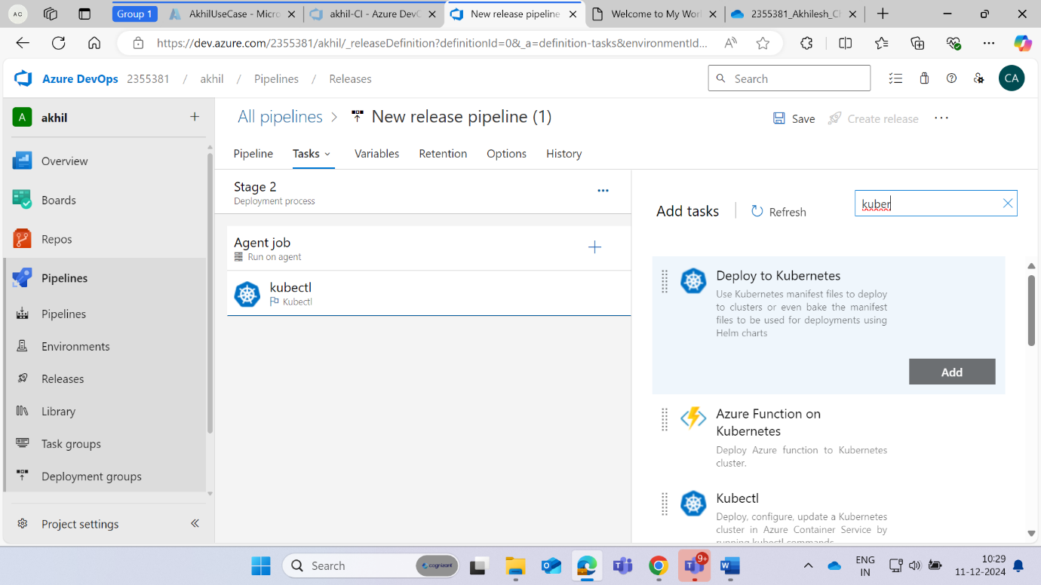

**Verify the cluster in the agent job section and give the name of the connection**

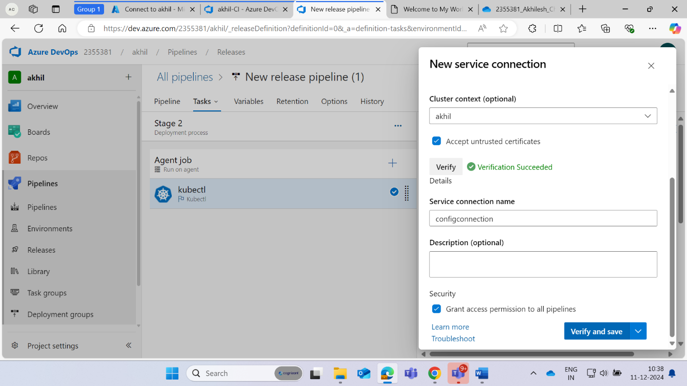

**Make some changes in kubectl**

**namespace = default and then go to new**

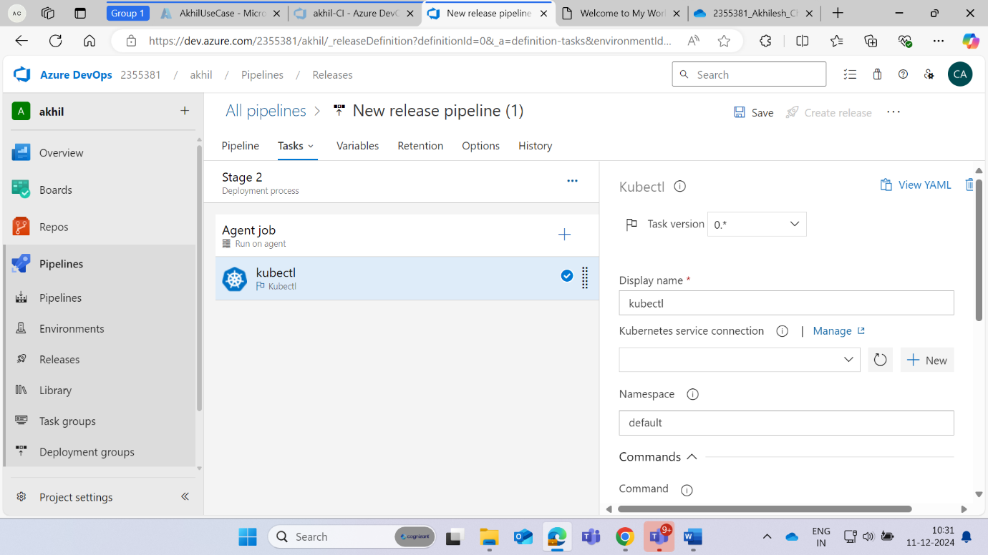

**Go to Kubernetes in Azure portal and open the cloud shell**

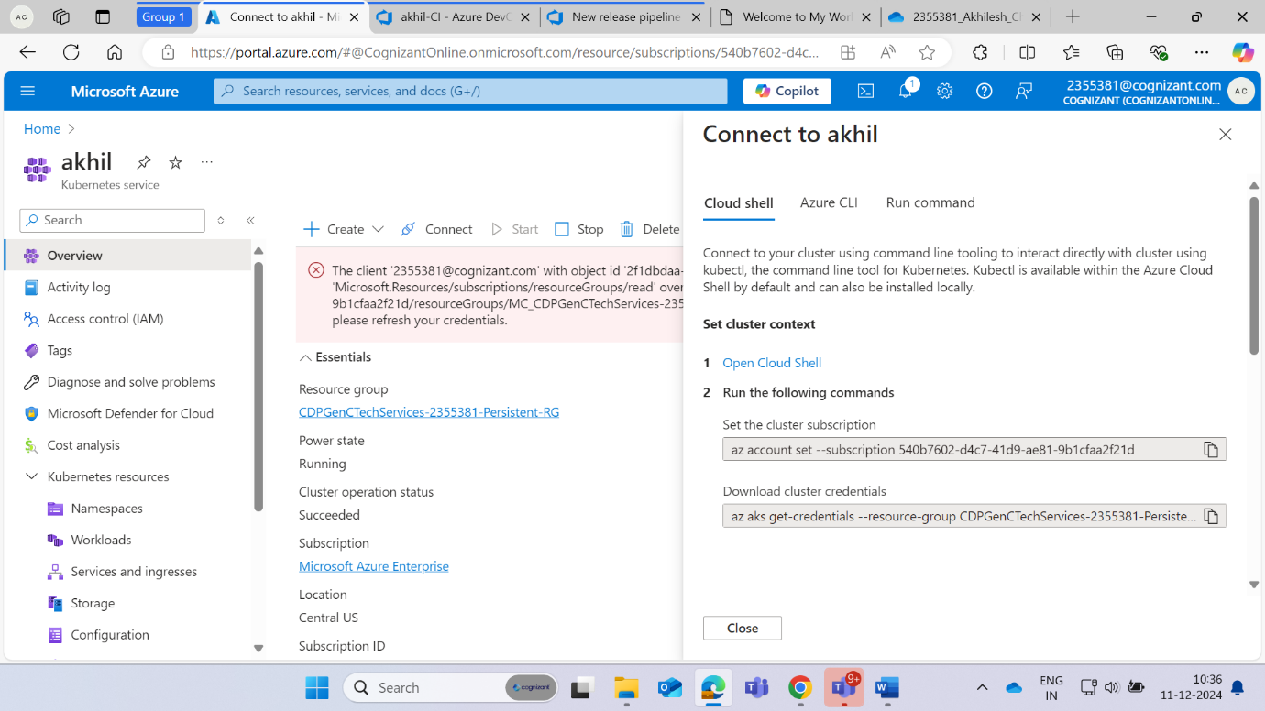

**Write the command ( cat .kube/config ) to get the configuration code**

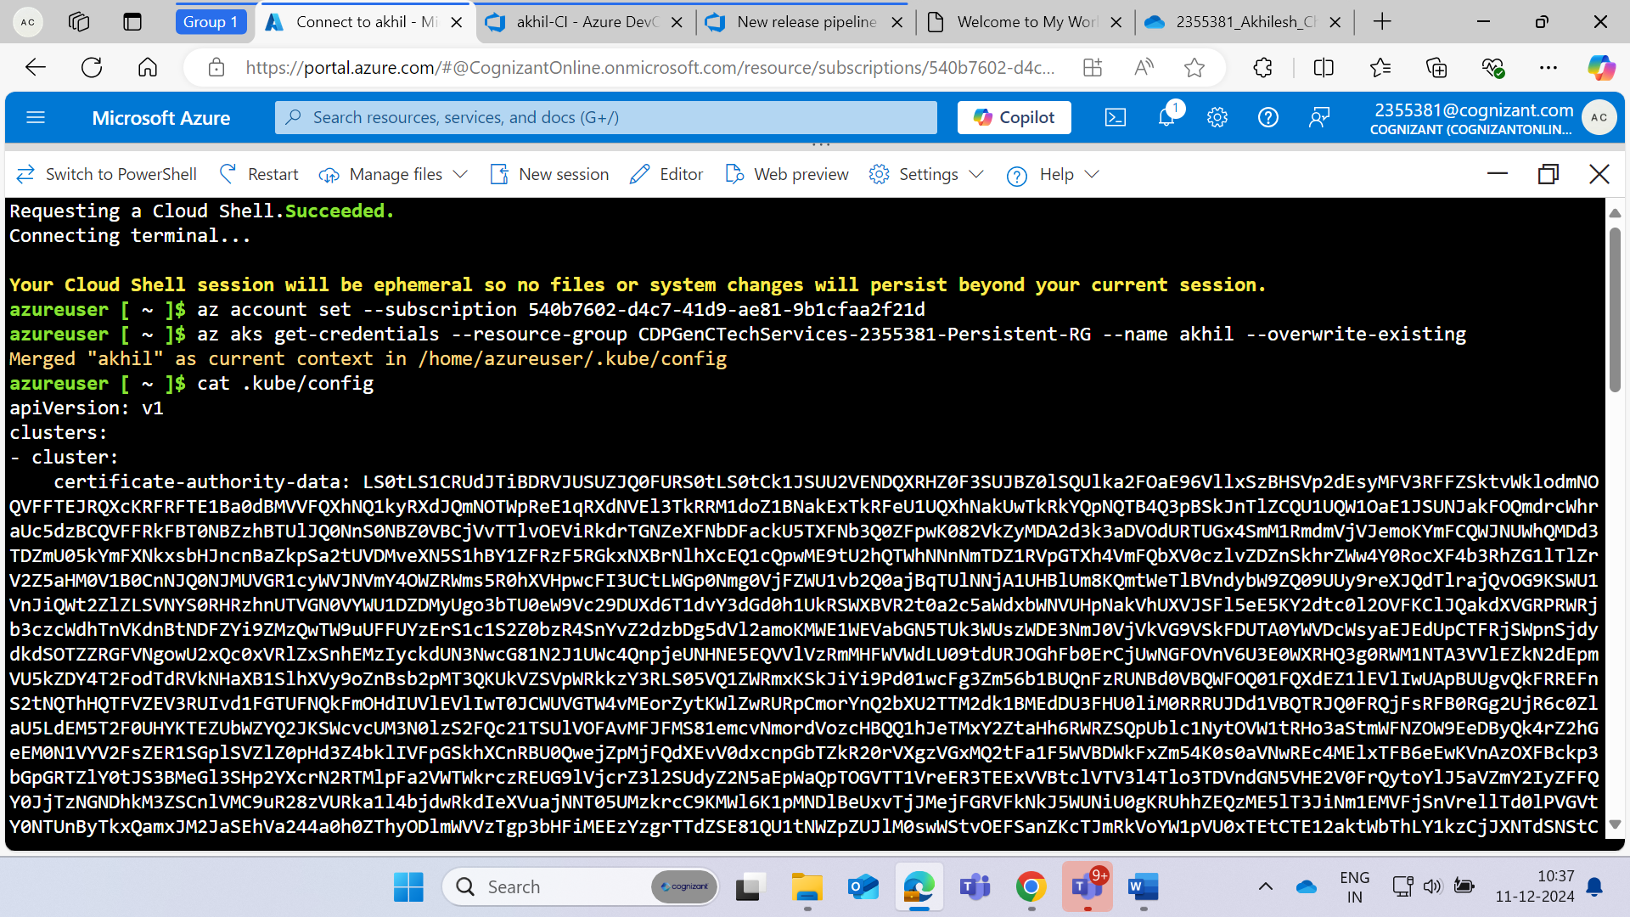

**Copy the above code and pate it to the kubeconfig section and verify it then give the service connection name**

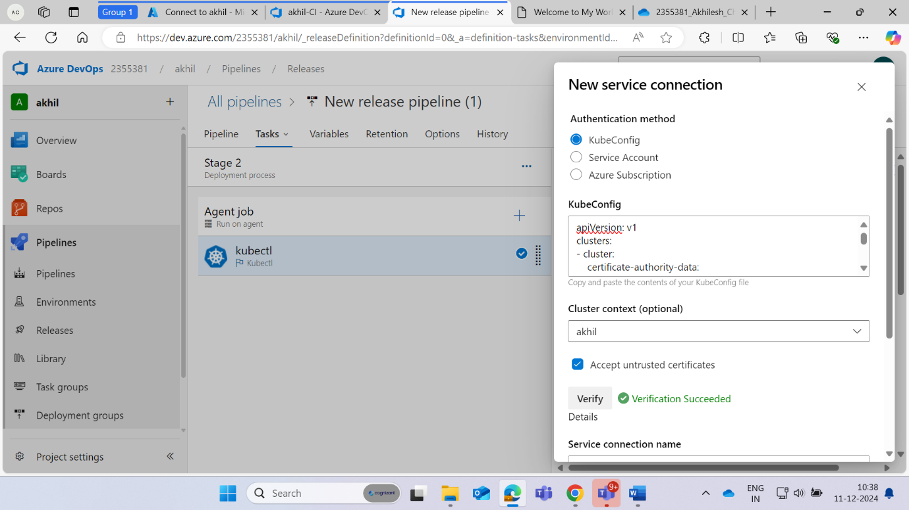

**Set Namespace as default and go to menifests and click on 3 dots**

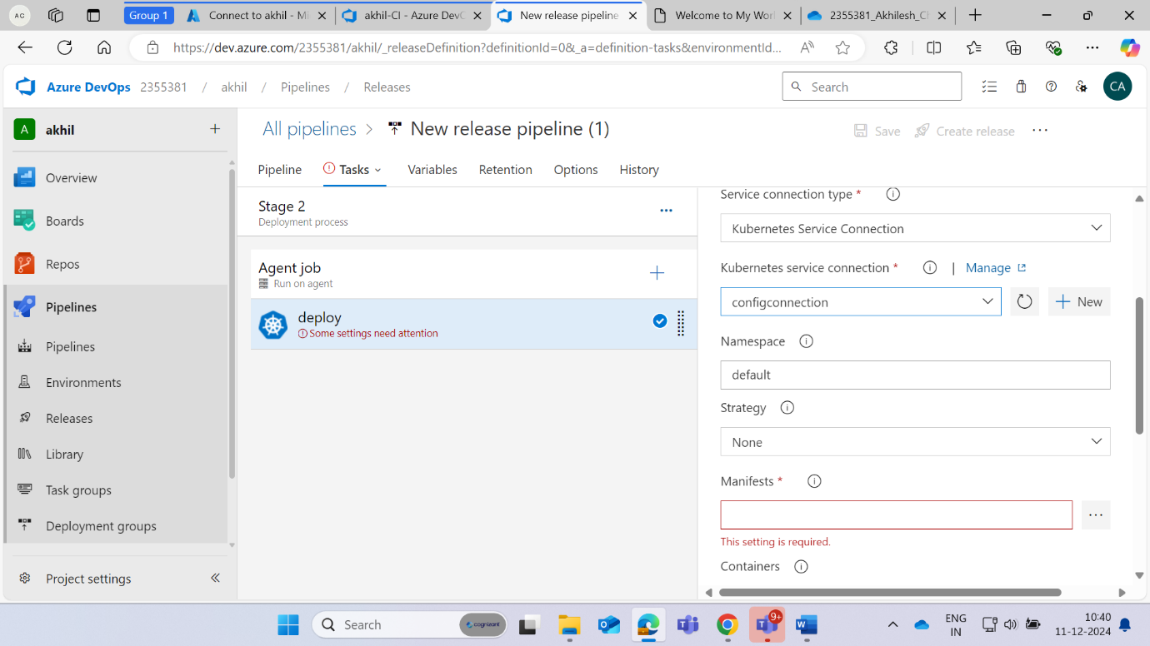

**Select the deployment file**

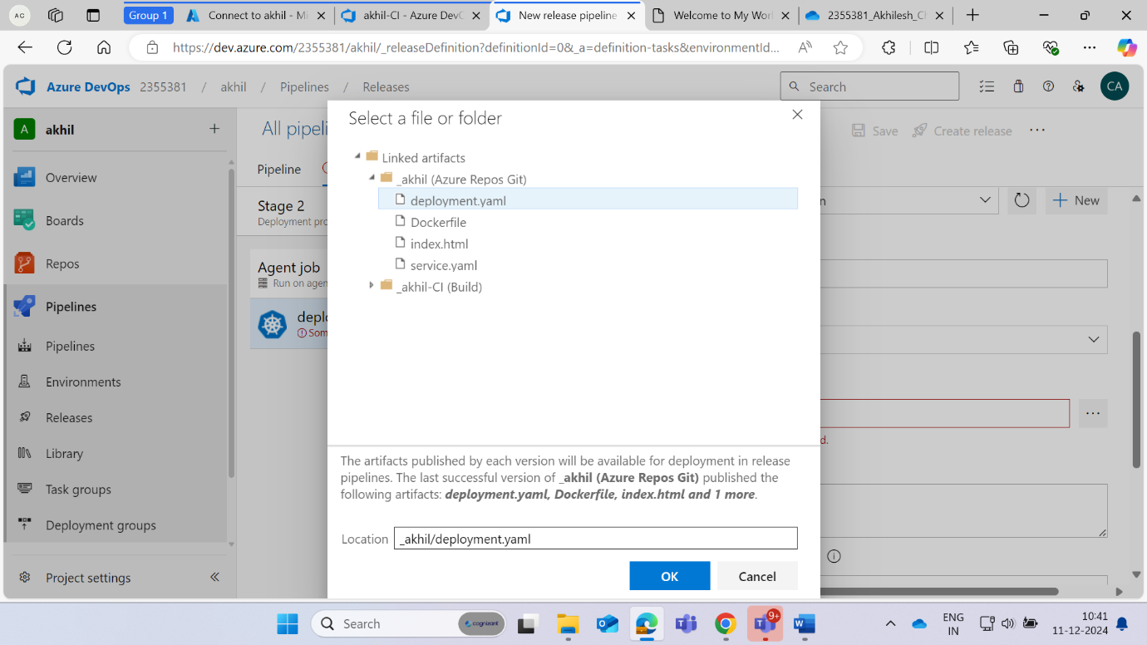

**Set timeout = 60 then save it**

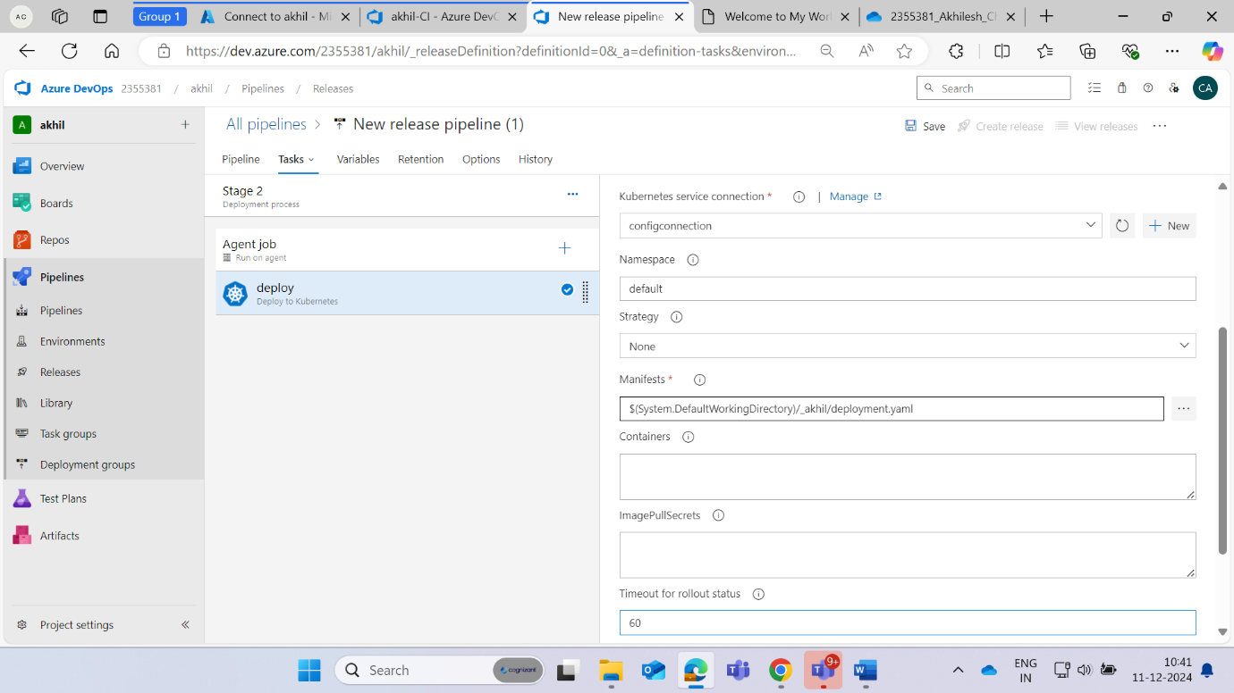

**Same Steps we must follow for service as we did with the deployment**

**Step 1:**

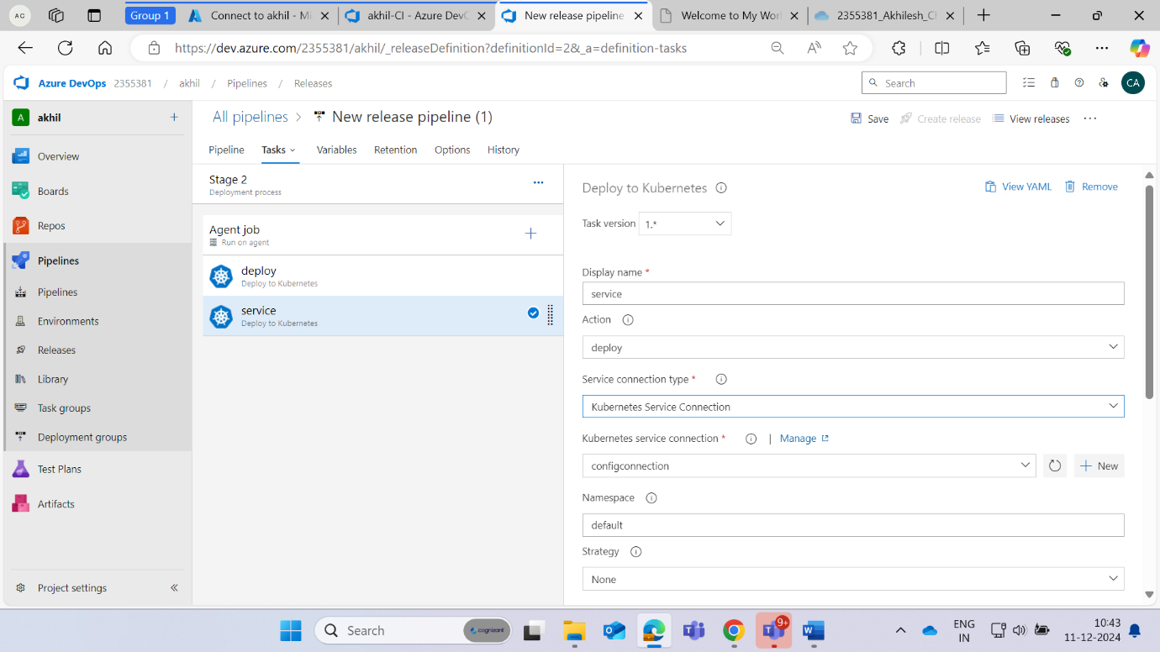

**Step 2:**

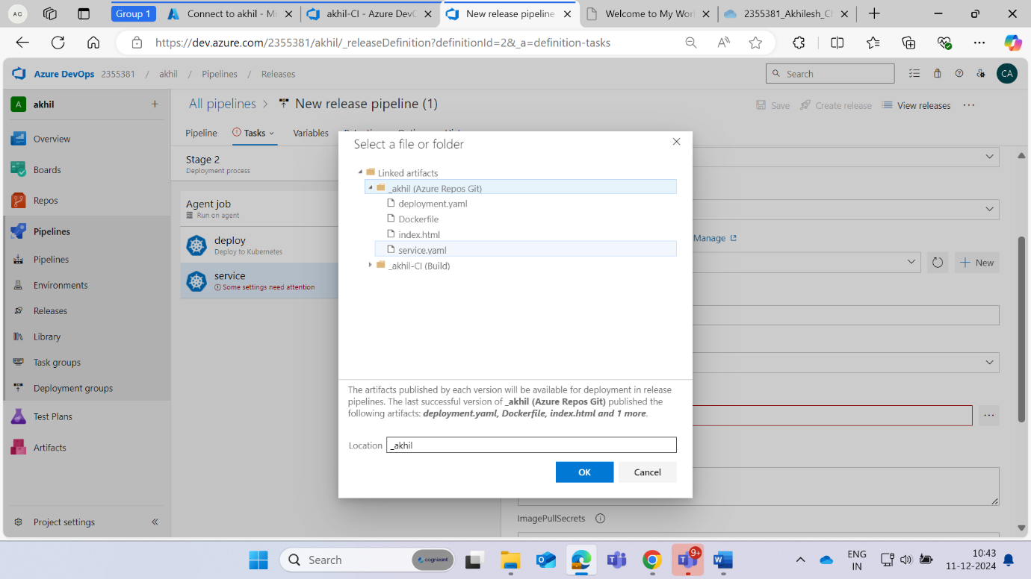

**Step 3:**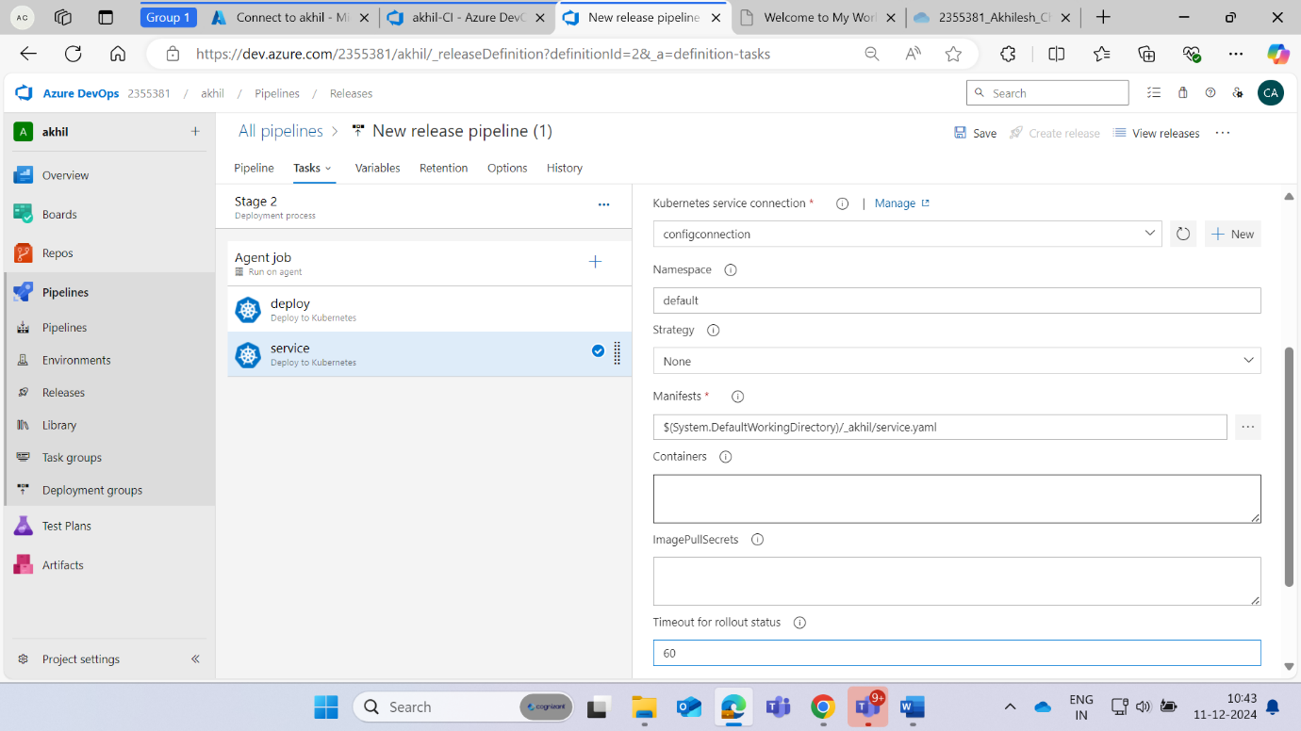

**Run the task**

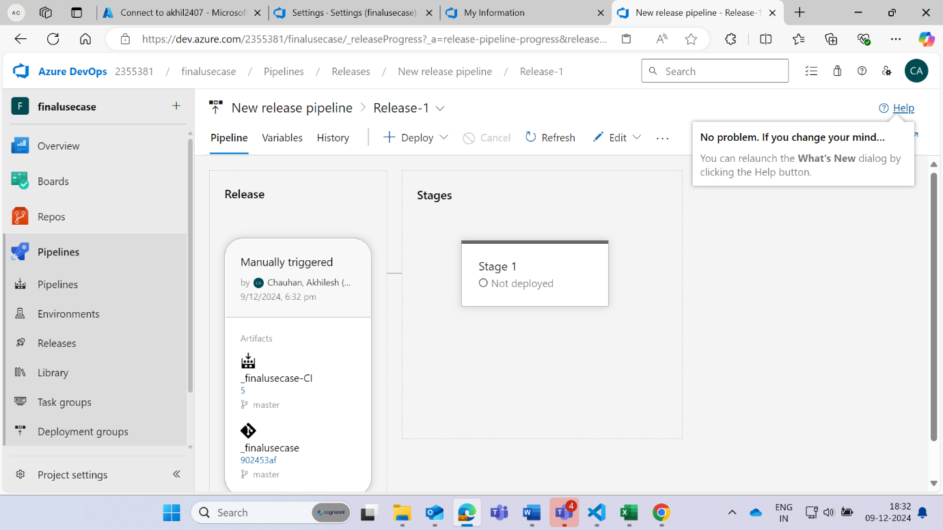

**Select the service**

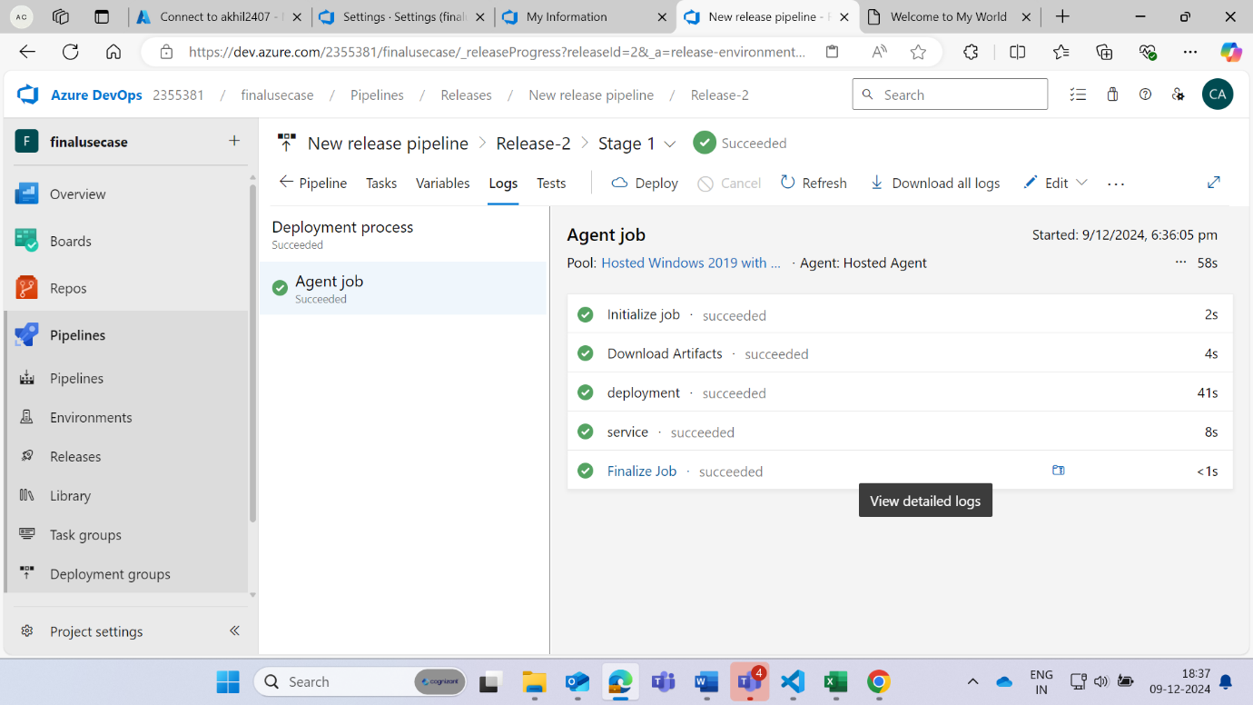

**Copy the ip and paste to the search engine**

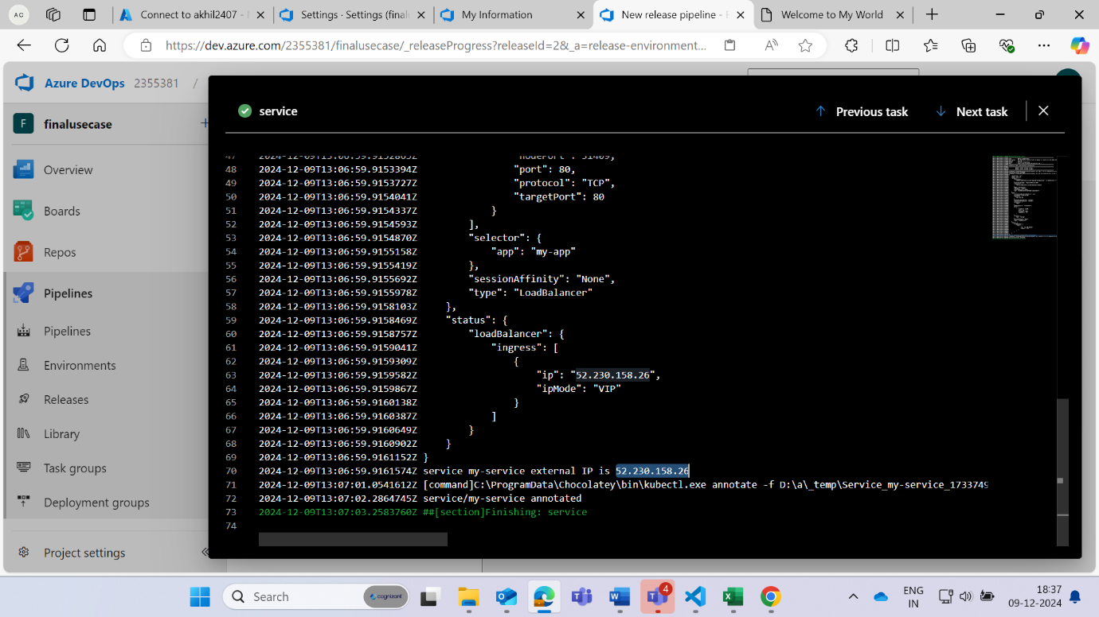

**The deployment is completed and Site is visible to the external ip**

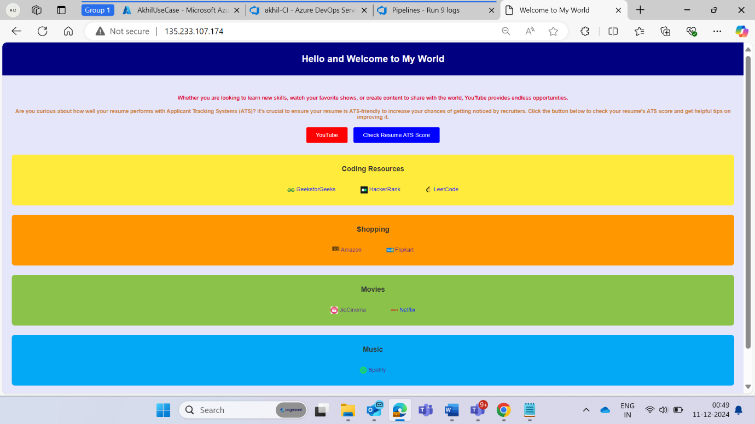

**There for in the above image we can see that the building and deployment task is 100% working**

